WHAT?
If there are any long term school closures, at Moat Farm Junior School we have the capacity to offer immediate remote education using Microsoft Teams as our online learning platform. We use Microsoft Teams (“Teams”) as a platform to deliver a planned and well-sequenced online curriculum that children can access from home. Teams allows pupils, teachers, and staff to seamlessly work together, create high quality content, plan and deliver daily interactive lessons, set daily assignments, provide effective and timely feedback, assess children and share resources all from one platform. Microsoft Teams allows our teachers to plan a programme that is of equivalent length to the core teaching pupils would receive at our school, including daily contact with their teachers. Teams can be accessed in many ways, for example, laptops, tablets; and there is also an app that staff, pupils and parents can download to use. By logging your child on to Teams, you are providing consent for your child to use Teams as per our school policies. Teachers will use Teams to teach and set assignments when needed, but to also provide positive praise and additional information with regards to any school work directly to the child through the class Teams wall.
At Moat Farm Junior School we have planned for three remote learning eventualities: class closure, year group closure and whole school closure.

Closure | Timetable | Planning | Virtual Lessons | Feedback
Class | Follow Appendix 1 | Continue to share year group planning as normal. Use daily AfL to adapt the planning to meet the children’s needs and address gaps. | Daily alongside support staff for the class, the teacher delivers:  1x Class Book Reading Session (15mins)  1x live English lesson  1x live Maths lesson  1x live Reading lesson  1x live afternoon lesson (choose from Topic, PSHE, RE, Science, Grammar and Arithmetic)  1x daily PE assignment (not live) -National Oak Academy or Joe Wicks. | Class teacher is responsible for marking work submitted by the children daily.
Year Group | Follow Appendix 1 | Continue to share year group planning as normal. Use daily AfL to adapt the planning to meet the children’s needs and address gaps. | Daily alongside support staff for the class, the teachers deliver to their own class:  1x Class Book Reading Session (15mins)  1x live English lesson  1x live Maths lesson  1x live Reading lesson  1x live afternoon lesson (choose from Topic, PSHE, RE, Science, Grammar and Arithmetic)  1x daily PE assignment (not live) -National Oak Academy or Joe Wicks. | Class teacher is responsible for marking work submitted by the children daily.
Whole School | Follow Appendix 1 | Continue to share year group planning as normal. Use daily AfL to adapt the planning to meet the children’s needs and address gaps. | Daily (lessons below will be shared out between class teachers who are working from home, class teachers who are at school and teachers who are planning across year groups):  1x Class Book Reading Session (15mins)  1x live English lesson  1x Maths lesson  1x live Reading lesson  1x live afternoon lesson (choose from Topic, PSHE, RE, Science, Grammar and Arithmetic)  1x daily PE assignment (not live) -National Oak Academy or Joe Wicks. | Class teacher is responsible for marking work submitted by the children daily.

HOW?
Pupils should:
- During a long term school closure, children should access their emails and Teams account during school hours only (8:45am - 3:15pm).
- Complete their weekly homework at a time that suits the household, this will be set on Teams every Thursday (deadline for return will be the following Tuesday).
- Use their emails to access Teams and seek support from their class teachers on the General Posts area of their class or year group. Children who do not follow the guidelines set in this Policy will have their emails temporarily disabled and parents will be contacted.
- Follow the Moat Farm Junior School values at all times when online (Motivation, Optimism, Achievement, Teamwork, Friendship, Respect, Acceptance and Manners).
- Follow our school’s E-Safety policy at all times.

UPLOADING LESSONS
Remote Learning Timetable
Teachers will upload, live stream and/or record lessons daily as per timetables (Appendixes 1 and 2). Work that the children submit is marked within 24 hours. This is monitored through Insights by the leadership team.

Lesson Worksheets
Wherever possible, uploaded lessons must be kept as straight forward as possible for the pupils and their parents to access.
- Lesson worksheets must be set on one page (a separate worksheet must be set for SEND pupils).
- Website links relevant to the lesson must be typed on to the lesson worksheet.
- Answer boxes/sections must be clearly provided for pupils to write the answers on. Work will not be marked if pupils’ answers are not submitted in the boxes/areas provided or if the answers are submitted through a photograph of their work.
- Teachers should continue to use daily AfL to plan and adapt the learning journey, in order to address misconceptions, challenge children and move the learning on.

Teaching a Live Lesson
Some lessons are live and taught by our teachers or cover teachers (HLTAs) only. Pupils and teachers will not plan for, or participate in, any live streaming from outside of our school and must always adhere to the following:
- The live lesson should take place in school time and must be supervised by teachers and support staff at all times (a minimum of two staff per lesson).
- Invite headteachers to all lessons so that lesson drop ins can still happen.
- Be sensitive to the needs of individual students, including deaf and disabled children, and children who may be sensitive to certain topics or issues that may arise during the livestream.
- Sit/stand against a neutral background.
- Teachers dress like they would for school.
- Double check that any other tabs they have open in their browser would be appropriate for a child to see, if they are sharing their screen.
- Use professional language.
- Teachers and support staff record all live lessons on Teams for safeguarding purposes.
- Teachers should be present in the lesson before the children join it and after the last child has left. To enable this, invites to lessons (meetings) are sent to the children ten minutes before the lesson starts.
- Invites to lessons are sent by the class teacher or member of staff leading the lesson.
- Parents and children are not permitted to use devices to record the live lessons, in any form, or to take photographs/screenshots. This includes uploading live lessons or images from the lessons on to any social media. If we become aware that this has happened, the child’s Teams account will be deactivated for up to 48 hours.
- Teachers will remove children from live lessons if they, or adults with them, are persistently disruptive.
- If children are persistently disruptive after repeated warnings within live lesson class chats and/or class teams chats, the children’s ability to post on the chats will be disabled for the duration of the lesson. If children continue to be disruptive once they are able to post again, their chat function may be disabled for up to 48 hours.

Role of the Support Staff in the Live Lesson
During the live lesson, support staff should:
- Be present at the start of the lesson to welcome the children in and leave after the last child has left.
- Press record as the first child enters the class.
- Take the register (Appendix 3) after each lesson and email it at the end of the day to SMT.
- Use the register to call the parents of children who did not attend the previous lesson to encourage them to join in to the next one and/or find out if there are issues that we can help resolve in order for the children to join.
- Contribute to behaviour management by regularly pinning children to ensure that they are concentrating and participating in the lesson.
- Support learning by continuously praising the children.
- Call the parents of any children, in between lessons, who do not attend the live lessons to offer support, assistance or encouragement to ensure the children attend daily. The calls will be made by the support member of staff who is working from home. Where classes have been paired up, support staff who are at home will be requested to also call the parents of the class which they have been paired up with. Therefore, the support member of staff in school must send the support staff at home a copy of the register after each lesson.

Recording a lesson
Teachers should try to find a quiet or private room or area record a lesson. When making a recording, teachers must:
- Sit against a neutral background.
- Dress like they would for school.
- Double check that any other tabs they have open in their browser would be appropriate for a child to see, if they're sharing their screen.
- Use professional language.

Children and parents must:
- Be in a shared space in their house.
- Enter meeting with their microphone muted and only unmute when asked by the teacher. If a child would like to ask a question or make a comment, they should use the ‘Raise a Hand’ function and wait to for the teacher to ask them to speak.
- Be mindful that other children and teachers might see and hear what is in their house.
- Wear school uniform.
- Keep their camera turned on at all times.
- We always encourage parents to be present when children are using the internet and live lessons is no different. If parents do have any queries about the lesson, they should email teamsupport@moatfarm-jun.sandwell.sch.uk as the lesson is for the children and teachers to communicate only.
FEEDBACK on LEARNING
Teachers (Remote Learning Only)
Teachers are split into year group or subject teams to share out the marking, while Microsoft Teams is developed as our home learning platform. This is to ensure that children learning at home receive feedback promptly on the work that they complete and submit. During this period of transition, teachers will be required to participate in giving feedback to work that has and/or has not been set by them.

When giving feedback:
- There is no requirement to tick or highlight correct/incorrect answers, simply praise children if all of the work is correct. If there are errors, pick one error to give feedback on and encourage the children to have another go and re-submit the work.
- If submitted work does not follow the instructions above (not written in answer boxes, submitted through a photograph, etc) teachers must feedback to the children explaining that the work will be marked once they have submitted it as requested.
- Work submitted by the children after the deadline set by teachers will not be marked.
- As parents/carers and children can now see staff’s comments and posts on Teams, it is important that email picture settings only contain a school photo of the staff member or no image at all (initials only).

Support Staff
Support staff are split into year group or subject teams to share out the marking, while Microsoft Teams is developed as our home learning platform. This is to ensure that children learning at home receive feedback promptly on the work that they complete and submit. During this period of transition, support staff will be required to participate in giving feedback to work that may be from a different year group to the one they are currently working in. The feedback required from support staff differs from the expectations of marking from teachers. Support staff will be asked to mark work by providing encouragement and praise to the children who have completed their work correctly or mostly correctly.

When giving feedback:
- There is no requirement to tick or highlight correct/incorrect answers, simply praise children if all or most of the work is correct.
- If a child has made a lot of errors, do not mark/return the work, teachers will provide a more detailed feedback to those children.
- As parents/carers and children can now see staff’s comments and posts on Teams, it is important that email picture settings only contain a school photo of the staff member or no image at all (initials only).

Communicating with Parents, Carers and Pupils
It is important for our teachers, support staff and pupils to maintain professional practice as specified in the Code of Conduct. When communicating online with parents and pupils, staff should:
- Communicate within school hours as much as possible (or hours agreed with the school to suit the needs of staff).
- Communicate through the school channels approved by the senior leadership team (Teams Only).
- Use school email accounts (not personal ones).
- Use school devices over personal devices wherever possible (Teams app on staff’s personal phones is permitted).
- Teachers and support staff should not share personal information.
- If a child is able to video call, voice call or send a message on Teams chat to a member of staff, decline/ignore and report this to a member of SLT.

Bullying or Abuse Online
Parents should report any bullying or abuse that occurred online directly to teachers through Teams, or parents and carers can report directly by calling the school.

Reporting Concerns
It is essential to have and communicate clear reporting routes so that children, teachers, parents and carers can raise any safeguarding concerns. Staff, parents and carers should report concerns as normal, following our Safeguarding Policy procedures.

Appendix 1
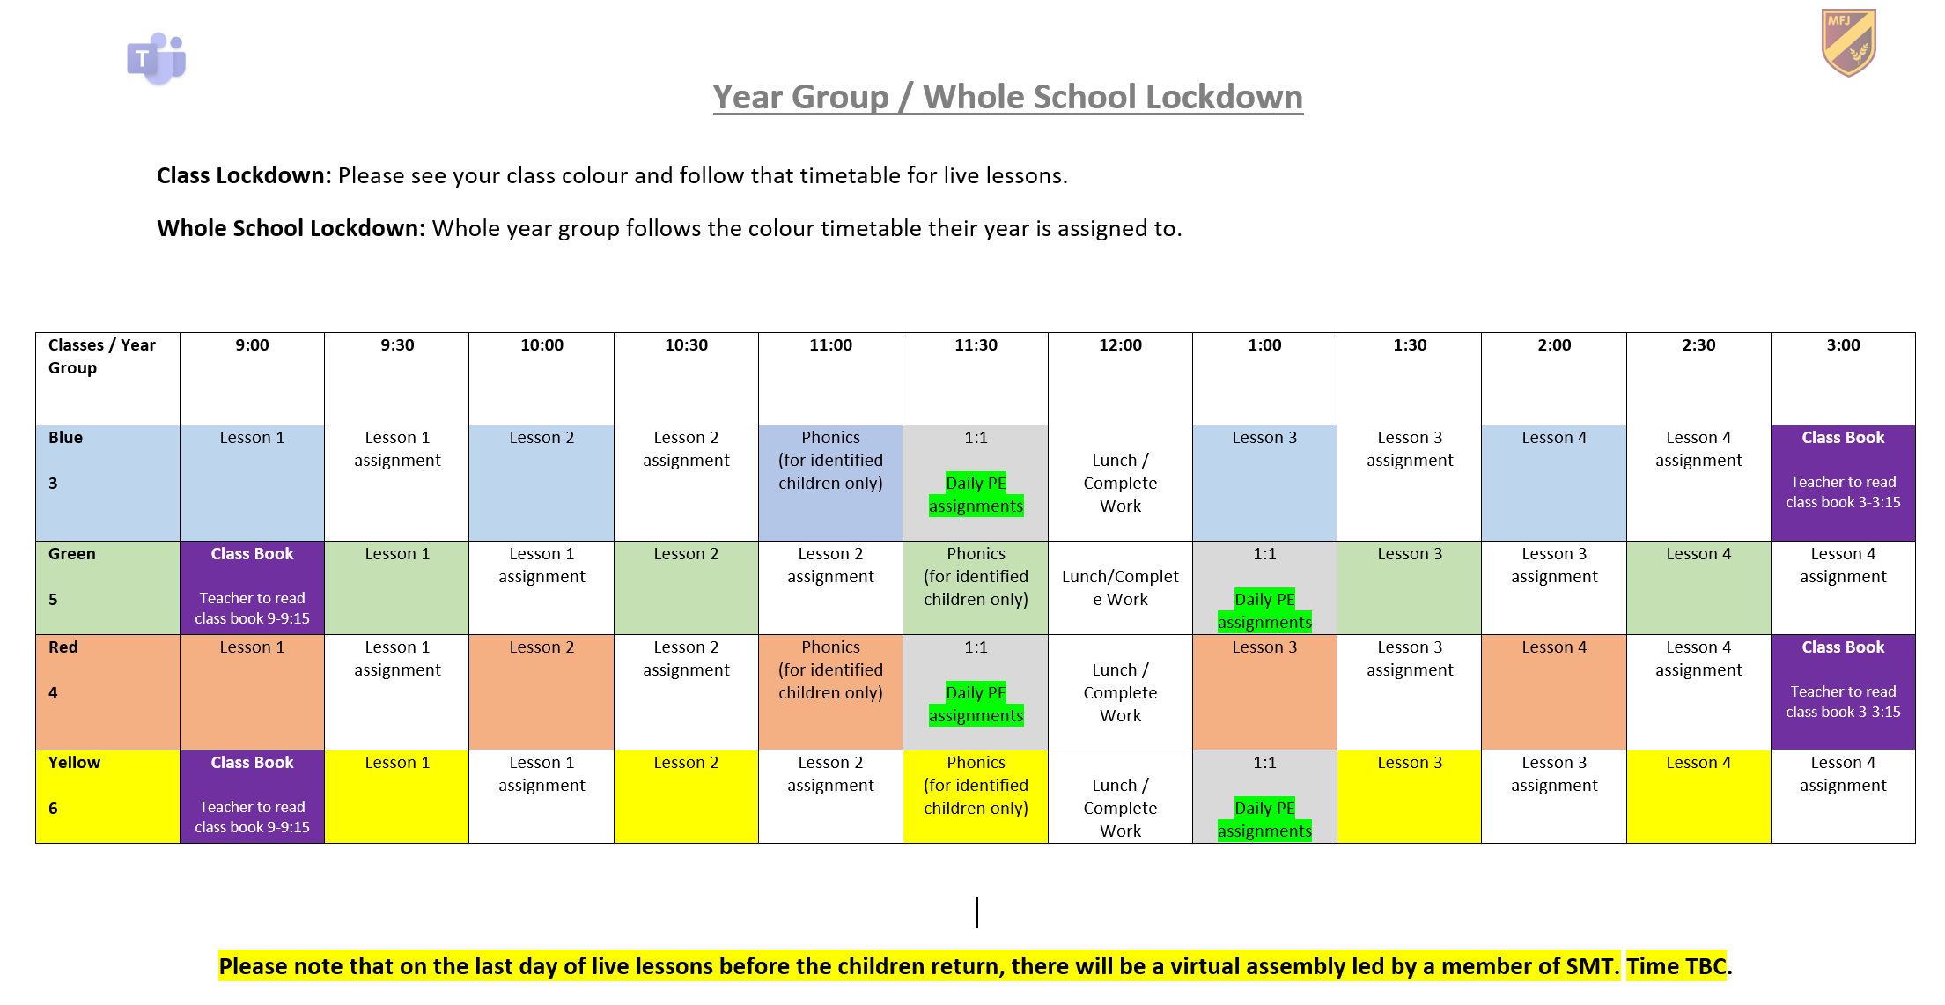

Appendix 2
Different types of Lessons Provided on Microsoft Teams Throughout Long Term School Closures
Live lessons | Teachers provide 4 daily live lessons to their class. This can then be followed up by an assignment or a quiz.
Pre-recorded Lessons | Lessons that are not live can be taught by pre-recorded videos that the teachers can share via email to their class. This can then be followed up by an assignment or quiz.
Assignments | Assignments are set so that the children can complete work and submit it to the teachers to mark, assess and plan the following day’s lessons accordingly.
Quizzes | Quizzes are set so that the children can complete work and submit it to the teachers to mark, assess and plan the following day’s lessons accordingly.

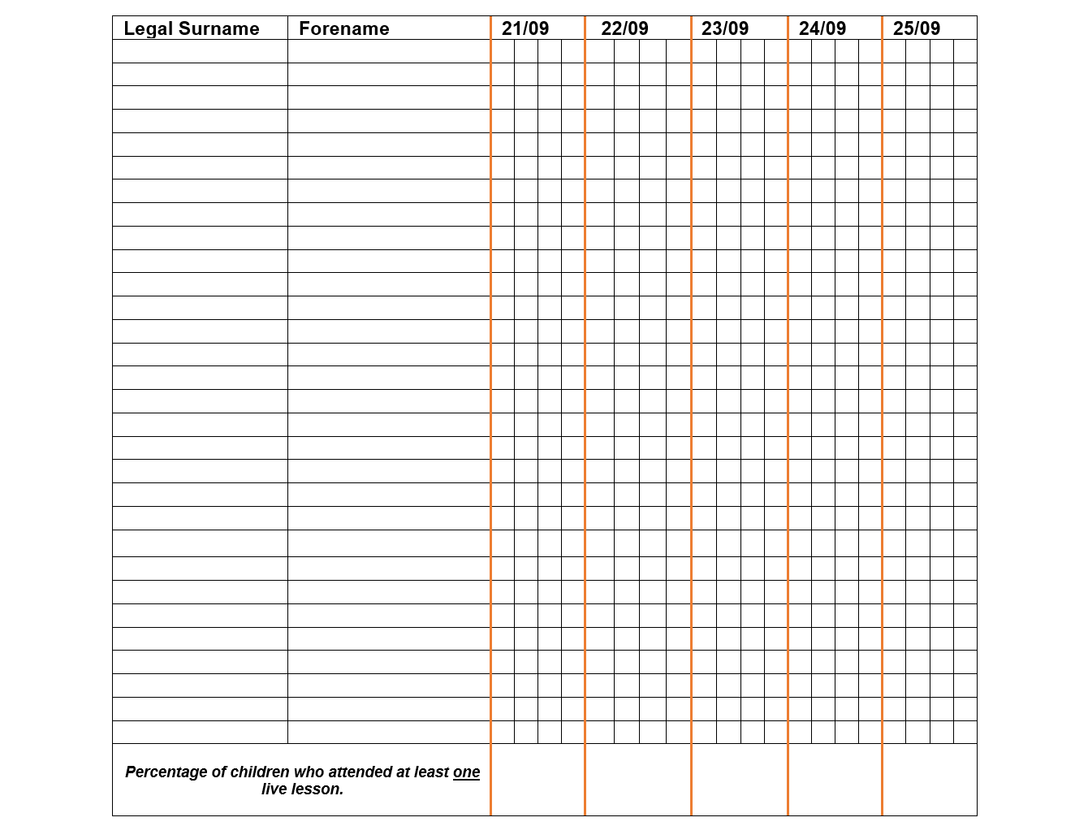
Appendix 3
Green - pupil attends a live lesson.
Red – pupil is expected to attend the live lesson but does not (this then needs to be followed up with a telephone call by the support staff member).
Yellow – a reason is provided for the pupil’s absence from live lesson / school (illness, childcare issue for that session, parental commitment, holiday etc).
Purple – a work pack is provided by school.
Blue – the pupil is awaiting a laptop or work pack.
Orange – Pupil is attending school.

