Moat Farm Junior School
Behaviour Policy 2023

Date Approved: October2023
Date for renewal: September 2024
Behaviour Lead: Miss J Roberts

Introduction
The school’s Behaviour Policy will be reviewed annually by the Behaviour Lead and Governors. It is available on the school’s website (for parents, pupils, staff and governors), on the school network (staff and governors) and in the staff room. This Behaviour Policy is also applicable when going on school trips and walking to/from school (anywhere where pupils are representing Moat Farm Junior School). This policy will still be applicable during these times and the same sanctions can be imposed if the incident has occurred on or off the school site.
This policy is part of our commitment to safeguarding children. It should be read in conjunction with our safeguarding policies and procedures, such as our Anti-Bullying policy. These policies can be found on our website https://moatfarm-jun.sandwell.sch.uk/policies/

Aims
As a whole school community we believe that in order to enable effective learning and teaching to take place, good behaviour in all aspects of school life is necessary. Staff and pupils are entitled to work in an environment free from violence and disruption. We seek to create a caring, learning environment by:
- promoting good behaviour
- promoting self-esteem, self-discipline, proper regard for authority and positive relationships based on mutual respect irrespective of gender, sexual orientation or faith
- ensuring fairness of treatment for all
- encouraging consistency of response to both positive and negative behaviour
- promoting early intervention
- providing a safe environment free from disruption, violence, bullying and any form of harassment
- encouraging positive relationships with parents and carers to develop a shared approach involving them in the implementation of the school’s policy and associated procedures
- accessing lead agencies related to supporting children who have SEN for behaviour

Our Behaviour Policy focuses on positive behaviour management, promoted and supported in the following ways:

- a carefully planned curriculum
- effective classroom management
- adult role modelling
- a whole school behaviour management plan
- playtime and lunchtime provision (structured playground games/lunchtime activities)
- personalised programmes /support from outside agencies if required.

At Moat Farm, we recognise that most children self-regulate their behaviour and behave well every day and never need reminding about how to behave appropriately. We want to encourage these children and, at the same time, also encourage the children who may not behave appropriately sometimes to self-regulate their behaviour positively. In order to do this, we have developed our Moat Farm Values.

Moat Farm Values
This policy sets out the expectations of behaviour at Moat Farm Junior School. We have high expectations for good behaviour, at all times, throughout the school day. At Moat Farm Junior School, all aspects of school life are underpinned by our Moat Farm Values.
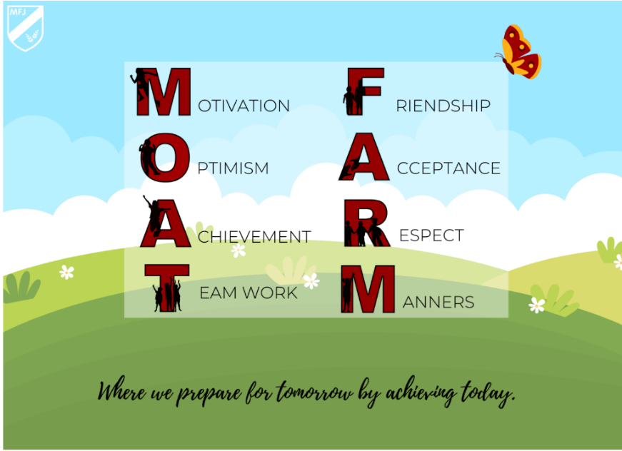

At Moat Farm Junior, we aim to broaden children’s horizons and raise aspirations by nurturing their ambition and confidence to pursue personal goals. We continuously link learning to real life situations and careers, while also instilling a sense of possibility and passion in our children to pursue what they enjoy, regardless of their background, gender or socio-economic status. We work together to increase our children’s confidence through exploring their many interests as well as expanding their knowledge of the world. We encourage fearlessness of what is new, unknown or difficult learning by creating exciting, inspiring opportunities in a fully supportive environment where their efforts play a key part. We recognise the importance of our children being resilient individuals, who are able to take risks and deal with different challenges across the curriculum and in the wider world by thinking positively and having the confidence to ‘have a go’. We work to develop the life skills necessary to work with growing independence and perseverance to become resourceful problem-solvers able to nurture aspirations for the future.

A strong aim within our curriculum is for our children to develop the skills necessary to communicate their thoughts, ideas and feelings successfully in a wide range of different forms. Children need to know how to speak and listen with respect in a variety of situations. We nurture our children’s awareness that actions have consequences and to make choices based on awareness, with the understanding that they have ownership of their actions. We believe children should have global awareness and feel responsibility for the part they play in it. At our school, children develop an understanding about where they live and the wider world. Through learning about the world, our children understand their role in society and develop respect towards the environment, communities and have cultural appreciation. At Moat Farm Junior, we want all children to value and respect all members of our community and to be a catalyst for positive change for all. Children are taught the skills for life to enable them to be good citizens and to contribute to the community. Our curriculum excites and motivates children about their learning by linking and embedding, within the curriculum, strong connections between education and their future. We prioritise our children’s ability to read well and read widely as this broadens horizons, develops imagination and provides a rich vocabulary through which to construct knowledge and understand the world.
We believe that our curriculum enables the children to develop the emotional understanding necessary in order to experience positive relationships and to develop a sense of justice and an ability to empathise that ensures a respect of themselves and each other. In our school, we endeavour to continuously develop a love for learning culture, where we will equip all children with the necessary skills in reading, writing and mathematics to succeed. We want children to be confident in asking questions and developing an enquiring mind which will help them reach their potential throughout their life as well as within lessons. We continuously praise the children’s efforts in order for them to love challenges, be intrigued by mistakes, enjoy effort, seek new strategies and keep on learning. Children are engaged by our curriculum that provides opportunities to excite the imagination, advance their knowledge and understanding through a wide range of creative, physical activities that take account of their diverse starting points and nurture their skills and talents, while enriching their experiences of life. Each one of our children’s abilities and needs are catered for in a personalised, individualised manner that supports and challenges them. This provision ensures that each child feels independent and proud of their accomplishments.
Roles and responsibilities
All staff, including teachers, support staff, staff in other roles and volunteers will be responsible for ensuring that the Behaviour Policy and procedures are followed, and consistently and fairly applied. Mutual support amongst all staff in the implementation of the policy is essential. Staff have a key role in advising the Behaviour Lead and Heads of School on the effectiveness of the policy and procedures. They also have the responsibility, with the support of the School Leadership Team, for implementing the policy and procedures consistently.
Staff have the responsibility to investigate behaviour complaints and issues, and then take the appropriate action in line with the Behaviour Policy and report all incidents. All staff will record incidents on SIMS.
The governors have the responsibility of guiding the Heads of School in determining the most appropriate measures to promote good behaviour. They have a key role in ensuring the Behaviour Policy and procedures are implemented consistently across the whole school. They also have a duty to regularly monitor behaviour reports and actions taken, to be aware of the effectiveness of this policy.
Staff will communicate the contents of the policy and procedures to children appropriately via individual conversations, PSHE lessons, displays, rule setting and assemblies. All staff will liaise with parents regarding any matter of concern regarding behaviour.
All staff are responsible for ensuring positive behaviour and will use preventative management strategies when required. All staff will ensure that they model good behaviour at all times, in all their dealings with children and other adults. Staff are trained in the use of emotion coaching language to promote positive behaviour in school.
Teachers need to ensure that the teaching and learning in their classroom is engaging, differentiated and that independent tasks are appropriately pitched and personalised to meet the needs of all pupils. The learning environment should support learning and resources and equipment must be well planned and prepared to support independent learning. The Behaviour Lead will undertake appropriate and consistent monitoring and recording of behaviour incidents and will liaise with members of staff ensuring the policy is followed fairly and consistently.
Parents and carers will be expected to take responsibility for the behaviour of their child/children both inside and outside of school. They will be encouraged to work in partnership with the school to assist the school in maintaining high standards of behaviour and will have the opportunity to raise any issues with the school.
Pupils will be expected to take responsibility for their own behaviour and made fully aware of the school policy, procedures and expectations through assemblies, lessons, displays, rule setting and individual conversations. Pupils also have a responsibility to ensure that incidents of disruption, violence, bullying and any form of harassment are reported.
Positive reinforcement
Our Behaviour Policy encourages positive interaction between all staff at Moat Farm. Rewards and appreciation for appropriate behaviour and attitude are widely available. The opportunities available to all pupils are:
- Praise – All staff are committed to ensuring that praise is given to the individual, group or whole class at all relevant opportunities, both inside the classroom and around school. Examples include praise being given to pupils who are being helpful, polite and setting a good example.
- House points- Each class can accumulate house points to be collated at the end of the week. The house (either yellow/blue/green/red) that has gained the most house points by the end of the week, will be rewarded with an extra five minute play.
- Stickers/certificates- All staff have a supply of rewards that are used to reinforce pupil effort and improvement and to promote consistently high-quality work.
- Postcards home – All class teachers will be expected to send three ‘surprise’ postcards every half term, by post, to acknowledge examples of excellent behaviour.
- Positive messages sent home - All members of staff have the opportunity to send a positive note home when deemed appropriate.
- Indoor/outdoor playtime resources- In order to enhance the quality of break and lunchtimes, a selection of equipment is available for all pupils to use in the playground. Other resources are available for use in the classroom during wet playtimes.
- PSHE Friday - Each Friday during PSHE lesson, children are given the opportunity to reflect on the past week and look ahead to the next. Pupils and teachers exchange thoughts, ideas and opinions, which are aimed to resolve conflict, set targets and improve the quality of life at Moat Farm.
- Individual Pupil Responsibilities - There are many opportunities for pupils to take on extra responsibilities these include: school council, classroom responsibilities, prefects, E-safety committee.
- Value Bands- At the end of each half term, class teachers select a student who they think has displayed each of the Moat Farm values. These children receive a wristband, which shows the value that they have been selected for.
- Congratulations Assembly - Weekly congratulations assemblies take place in upper and lower school each Tuesday from 8:50 -9:05am. Awards include class star pupil of the week, upper/lower school class attendance and punctuality, one upper/lower school Heads of School award and additional awards such as times table certificates, swimming badges and other sporting awards.
- Pupil of the Term Assembly - At the end of each term, a special assembly is held to celebrate the pupils who have been given the class Pupil of the Term Award for effort, progress, improvement or maintenance of high standards. These pupils are awarded a prize and a certificate.
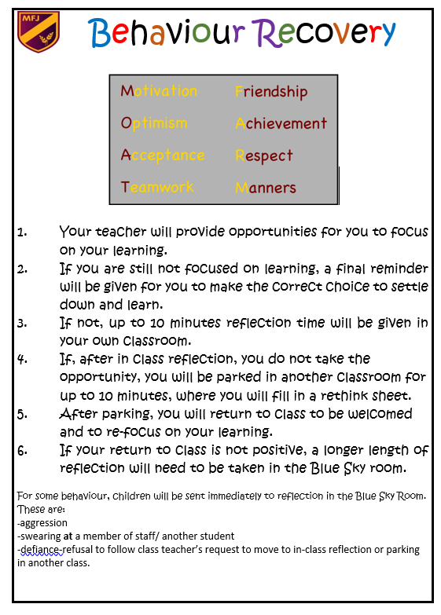
Behaviour Recovery
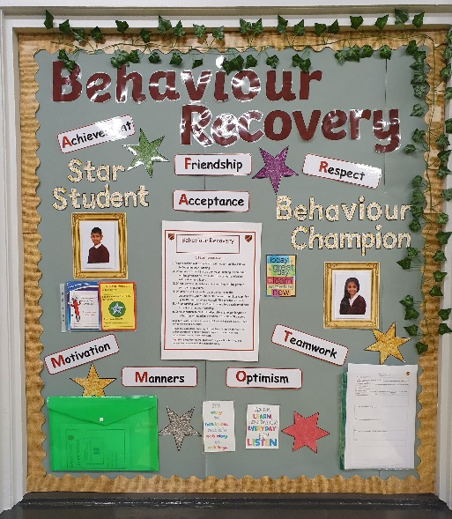
Moat Farm Junior School follows the ‘Behaviour Recovery’ behaviour management system. At the start of the autumn term, all staff were trained and updated on the system and the stages of Behaviour Recovery. Every classroom has a dedicated Behaviour Recovery display and reflection table so that the same, consistent message is provided across school. This display also contains a visual reminder of the stages of behaviour recovery, written in appropriate child-friendly language.

If children are deemed to be ‘off task’ by an adult in their learning environment, the Behaviour Recovery system begins.

- Stage 1 - Reminders: Teachers/support staff use a range of behaviour management strategies to manage low level disruption and aim to get the child back on task and focused on their learning – e.g. standing near the child, asking to see their work, asking if they’re okay with the task set, making eye contact with them, praising others on task.
- Stage 2 - Warning: If the unwanted behaviour continues, an adult quietly speaks to the child and gives them a warning explaining that they have tried a range of strategies which the child has not responded to. The adult then explains that if the child continues to choose not to get on with their work/settle down, then an alternative will need to be tried.
- Stage 3 - In class reflection: After this final warning, if the child’s behaviour is still not corrected, the child is instructed to ‘reflect’ at the designated reflection table within their classroom, for up to ten minutes. The adult uses their own judgement for how long is needed for reflection. The child is then expected to return to learning fully focused and on task.
- Stage 4 – Parking: If the child still does not return to purposeful learning after in class reflection, the adult explains that the child is going to be parked in another class. The child is sent to another class to sit at their dedicated reflection table and fills in a reflection sheet. After approximately ten minutes (adult’s judgement), the child returns to their own class. On arrival, the class teacher is positive, welcoming and explains what tasks need to be completed.
- Stage 5 - Blue Sky Room: If a child still does not correct their behaviour following parking in another classroom, they are sent or taken to our Blue-Sky room for a longer period of reflection. Here, a member of the Senior Leadership Team manages a conversation with the child and gets them to reflect on their chosen behaviour and gets them to fill in a re-think sheet. When the member of SLT thinks that the child is calm/happy/safe enough to return to class, they accompany them back to their classroom, where, again, the class teacher welcomes them back to their learning environment.

Throughout the Behaviour Recovery system, children are provided with opportunities to self-correct their behaviour. They are given chance to gather their thoughts, re-focus and then make changes to the behaviour they have demonstrated in class. When a child does correct their behaviour, praise is provided, and they are encouraged to make these positive choices at all times.

At lunchtime, the Behaviour Recovery system is used in a similar way. Children are asked to sit/stand by an adult for reflection and can be parked on another playground. On some occasions, ‘Blue Sky’ will take place during the following day’s lunchtime.

On some occasions, there may be certain behaviour displayed in class, which would result in a child being sent to the Blue Sky room, without the previous stages being implemented by the class teacher. These are for example:

- Aggression for example shoving another member of the class, deliberately throwing a chair, water bottle etc.
- Swearing at a member of staff/ another student.
- Defiance/refusal to follow the class teacher’s request to move to in-class reflection or parking in another class.

Class teachers or a member of SLT may consider, depending upon the circumstance, it is important for parents/carers to be informed of a child being sent to the Blue Sky room for reflection. If so, they will be contacted via telephone or asked to come into school to discuss the matter further.

On some occasions, where a pupil is considered to be at risk of harming themselves or someone else, it may be necessary to restrain a pupil. This will be in line with the following guidance:
https://www.gov.uk/government/publications/use-of-reasonable-force-in-schools
Please see Moat Farm Junior School’s Physical Restraint Policy for further information. https://moatfarm-jun.sandwell.sch.uk/policies/
Red Sky - Some ‘bottom line’ behaviours may result in Red Sky being used. This would include for example:
- Serious assault of an adult or child, including child-on-child abuse (see section below)
- Deliberate and intended use of offensive language, including racist and homophobic
- Theft
- Vandalism of school or another person’s property
- Bullying (persistent and deliberate abuse of another student) including cyber bullying, prejudice-based and discriminatory bullying. Any incidents of bullying will be referred to SLT to record in the bullying log. The school’s Anti Bullying Policy provides more information. This policy can be found on our website https://moatfarm-jun.sandwell.sch.uk/policies/
- Prolonged and persistent disruption to the learning of others as deemed to be inappropriate by the school’s Senior Leadership Team, for example, when behaviour escalates to ‘Blue Sky’ regularly for disruption/not being focused within the class.
For these type of incidents, parents/ carers will be contacted via telephone or asked to come into school to discuss the matter further.

Behaviour Trackers

If there are persistent behaviour issues, children will be laced on a behaviour tracker which will be monitored by SLT on a daily basis. This is a short term measure with the aim for children to self-correct their behaviour.

Child-on-child sexual harassment.
Following any report of child-on-child sexual violence or sexual harassment offline or online, Moat Farm Junior School follow the general safeguarding principles set out in Keeping children safe in education (KCSIE) - especially Part 5. https://www.gov.uk/government/publications/keeping-children-safe-in-education--2
The Designated Safeguarding Lead (or deputy) in conjunction with the Senior Leadership Team will decide on the initial response. Each incident will be considered on a case-by-case basis.
At Moat Farm Junior School, sexual violence and sexual harassment are never acceptable, will not be tolerated and pupils whose behaviour falls below expectations will be sanctioned. As part of ongoing training in school, the importance of challenging all inappropriate language and behaviour between pupils is made clear to all staff.
We will never normalise sexually abusive language or behaviour by treating it as ‘banter’, an inevitable fact of life or an expected part of growing up. We advocate strenuously for high standards of conduct between pupils and staff; consistently demonstrating and modelling manners, courtesy and dignified/respectful relationships.
It is essential that all victims are reassured they will be supported, kept safe, and are being taken seriously, regardless of how long it has taken them to come forward. Abuse that occurs online or outside of the school should not be downplayed and should be treated equally seriously. A victim should never be given the impression that they are creating a problem by reporting sexual violence or sexual harassment. Nor should a victim ever be made to feel ashamed for making a report or their experience minimised.
Provision for children with additional needs
It is important that we recognise that children with SEND and additional needs learn and develop in different ways. Therefore, the routines and sanctions will be adjusted to meet the individual needs of these pupils. This may include pupils with ASD, ADHD, learning disabilities, physical disabilities, anxiety and many other needs. The decision to adjust routines and sanctions will be made on an individual case by case basis.
Additional school-based support is available to pupils, through 1:1 mentoring, small group pastoral support and behaviour interventions. Additional support and advice is also available from Mental Health Support Teams and counsellors from agencies such as Murray Hall, Kaleidoscope and Sandwell CAMHS.
There is ongoing engagement with Sandwell Inclusion Support, which includes the Specialist Advisory Teachers for SEMH (social, emotional and mental health) and Educational Psychologists. The school will follow the graduated approach when seeking advice and support from Inclusion Support in assessing the needs of pupils who display continuous disruptive behaviour. This advice will be sought in conjunction with the parents/ carers.
This policy forms part of the whole school approach to mental health and wellbeing as set out in the Mental health and behaviour in schools guidance. https://www.gov.uk/government/publications/mental-health-and-behaviour-in-schools--2
This policy also recognises our legal duty under the Equality Act 2010 in terms of safeguarding and supporting pupils with special educational needs.
Pupil transition
At the beginning of each academic year, the behaviour expectations, sanctions and rewards are communicated to all pupils, through assemblies, PSHE lessons and classroom discussions.
When pupils join the school at the beginning of Year 3, behaviour expectations will form part of the induction visits and will be reinforced as the new academic year begins.
If a pupil joins the school as a mid-year transfer, the behaviour expectations will form part of their induction.

Reporting a behaviour incident on SIMS
When a behaviour incident occurs in school, the incident needs to be reported on SIMS, so that the Behaviour Lead can monitor behaviour incidents. To report a behaviour incident, the following steps will be followed: search the child’s name in the search bar, click on ‘behaviour’, click on ‘new’, fill in the details it requires such as: type of incident, who was involved, what happened, staff involved etc. and then save the information that has been recorded.
On a half-termly basis, the Behaviour Lead will analyse the recorded incidents of behaviour to identify patterns and take appropriate action. This analysis should also ensure that no particular groups are more affected by the policy than any other group.

Staff Induction, development and support.

At the start of each academic year, the Behaviour Lead and Senior Leadership Team will ensure that training on the management of behaviour takes place for all school staff. Training will also include matters such as how certain special educational needs, disabilities or mental health needs may at times affect a pupil’s behaviour.
When a new member of staff joins the school during the academic year, training on behaviour management will form a part of their induction process.
Throughout the year, it is expected that all staff will consider the impact of their own behaviour on the school culture and will consistently uphold the school rules and expectations. Additional support is available from the Behaviour Lead for staff that may need to improve their own practice.
Suspensions
Lunchtime Suspension
Pupils whose behaviour at lunchtime is disruptive may be suspended from the school premises for the duration of the lunchtime period. Lunchtime suspensions are counted as one half of a school day for statistical purposes. These suspensions are not affected by the new regulations on providing pupils with education from the sixth day of their suspensions. Taking into account the child’s age and vulnerability, the Heads of School will ensure that a parent/carer has been contacted and is available to collect the pupil and supervise during lunchtime. Free school meal entitlement must be honoured.
A lunchtime suspension for an indefinite period, like any other suspension, would not be lawful. The guidance suggests that this strategy should not be used for long periods of time.
Suspension
A decision to suspend a pupil for a fixed period should be taken, on the balance of probabilities, only in response to breaches of the school’s behaviour policy where these are not serious enough to warrant permanent exclusion. Individual fixed period suspensions should be for the shortest time necessary, bearing in mind that suspensions of more than a day or two make it more difficult for the pupil to reintegrate into school following a suspension. Ofsted inspection suggests that 1-3 days are often long enough to have the desired effect without adverse educational consequences.
A school can make the decision to suspend for a maximum of 45 days in one academic year. When a pupil is given a suspension for six days or longer, the school has a duty to arrange suitable full time education provision from and including the sixth school day of the suspension.
When a pupil receives three suspensions in one term, this should trigger a CAF (Common Assessment Framework), which could then lead to a TAC (Team Around the Child) meeting. When a pupil has received fifteen days suspension in one term, this should then be presented to the Governors to review the case. Both of these measures are used as a strategy to prevent a permanent exclusion.
Full time education must be provided from the first day for children in care (Looked After Children). Schools must arrange reintegration meetings for all pupils following a suspension. Return to school cannot be delayed if a parent is unable or not willing to attend this meeting.

Continued disruption in lessons and school | 1-3 Days
Defiance | 1-3 Days
Verbal abuse to staff/pupils/others | 1 Day
Racial abuse to staff/pupils/others | 1 Day
Bullying – Physical/Verbal | 1+Day
Physical abuse to staff/pupils/others | 1+Day
Sexually inappropriate behaviour | To be determined.
Theft | 1-3 Days
Vandalism | 1-3 Days
Extortion | 1-3 Days
Threatening behaviour | 1-3 Days
Setting off fire alarm | 1-3 Days.
Examples of behaviour types that warrant a suspension:

After investigation, the Heads of School can cancel any suspension that has already begun, but this should only be done where it has not yet been reviewed by the governing board. Where a suspension is cancelled, then parents, the governing board, and the Local Authority will be notified. Parents have the opportunity to meet with the Heads of School to discuss the circumstances that led to the suspension being cancelled. The pupil should be allowed back into school.

This table is a guide only and draws on current practices in Sandwell Primary Schools. The number of days given to the pupil is at the discretion of the Heads of School. The days illustrated above are a guideline only and longer suspensions (including permanent exclusions) may be implemented depending on the severity of the offence.

Guidance in relation to representation from parents/carers:

If total is five school days or less Governors do not have to meet but it is good
practice to do so.
If total is 5-112 school days or more | Parents have the right to put a case to the Governors – they are able to remove the suspension from the pupil’s school record if appropriate.
Suspensions that total fifteen school days or more in one term | Governors should review the pupil’s case

Reintegration Interviews

A senior member of staff should arrange and conduct a reintegration interview with a parent and the pupil at the end of the suspension, at a date and time convenient for the parent on the school premises. The notice for a reintegration interview must be given no later than six school days before the date of the interview (it can be combined with the notice of the suspension). If the parent fails to attend, the school must keep a record of the failure as well as any explanation given as it can be one factor taken into account in the Magistrates’ Court when deciding whether to impose a parenting order. As a primary school we will offer a reintegration interview after any suspension.

Permanent Exclusion
The decision to permanently exclude can only be made by the Heads of School. A decision to exclude a pupil permanently should be taken only in response to serious breaches of the school’s Behaviour Policy and if allowing the pupil to remain in school would seriously harm the education or welfare of the pupil or others in the school. This decision is a serious one and should only be taken when all the facts and evidence are clear. In some circumstances, it will be necessary to put a suspension in place pending the outcome of an investigation. This should be as short as possible and work should either be sent home or accessed via Teams.
There will be exceptional circumstances that lead to permanently excluding a pupil for a ‘one off’ incident. These could be:
- Serious actual or threatened violence against another pupil or member of staff
- Sexual assault / abuse
- Supplying an illegal drug/alcohol
- Carrying an offensive weapon
When a pupil is involved in a criminal activity, the school should consider whether or not to inform the police. The outcome of the police investigation does not have to have reached its conclusion before the Heads of School make their decision. Once the Heads of School have made the decision to permanently exclude a pupil, they need to contact the Local Authority to advise them in order for the statutory Day 6 education provision to be made by the Authority (Day 1 for ‘Children in Care’). The Heads of School should carefully follow the procedures set out in law, which are designed to ensure fairness and openness in the dealing of permanent exclusions.

Correspondence to the parents/ carers must clearly indicate the following:
- reason for the permanent exclusion and effect from what date
- the parent’s right to make representations about the exclusion to the governing body and how the pupil may be involved in this
- the contact details if they wish to make such representation (this is normally the clerk to the Governors).
- the school days on which the parent is required to ensure that their child is not present in a public place during school hours without justification and that the parent may be prosecuted, or may be given a fixed penalty notice, if they do not do so.
- the arrangements that have been made enabling the pupil to continue with his / her education (Day 6 provision)
- the latest date by which the governing body must meet to consider the exclusion (15 school days from the date of permanent exclusion letter)
- the parent’s right to see and have a copy of their child’s records upon written request to the school
- the name and telephone number of an officer from the Local Authority who can provide advice as well as contact details for ACE (Advisory Centre for Education).

Within one school day, the Heads of School must inform the governing body and the Local Authority of permanent exclusions. If the pupil lives outside the Local Authority where the school is located, then the ‘home’ Local Authority need to be advised in order for them to provide the statutory Day 6 provision.

The clerk to the Governors is responsible for arranging the meeting of the Discipline Committee meeting, ensuring that there are at least 3 Governors available. The Clerk will need to minute the meeting. The statutory guidance is that this meeting must take place within fifteen school days from the date of the permanent exclusion.

The school need to collate all the relevant paperwork and to ensure that the family receives this paperwork at least 5 days prior to the Governors meeting. The Governors as well as the Local Authority representative, will also need copies of the paperwork provided again at least 5 days prior to the governors meeting. Once the governing body have heard the case, then the clerk to the Governors will inform the family of the decision within one working day, clearly stating in the letter that the family have the right to appeal against the decision before an Independent Appeal Panel. In the appeal letter the contact details to whom the request for the appeal must be made to should be clearly identified as well as the date by which the letter needs to be received by (the family have fifteen school days in which to appeal). On receipt of a letter requesting an appeal, the Local Authority has fifteen school days in which to hear this appeal.

Prohibited items and searches
Heads of School and staff have a statutory power to search a pupil or their possessions where they have reasonable grounds to suspect that the pupil may have a prohibited item or any other item that the school rules as an item which may be searched for. Prohibited items include:
- knives or weapons
- alcohol
- illegal drugs
- stolen items
- tobacco and cigarette papers
- fireworks
- indecent images
- any article that a member of staff reasonably suspects has been, or is likely to be, used to commit an offence or injure a person or damage property.
This is not an exhausted list.
A search can be considered if a member of staff has reasonable grounds for suspecting that the pupil is in possession of a prohibited item. Before any search takes place, the member of staff conducting the search will explain to the pupil why they are being searched, how and where the search is going to take place and give them the opportunity to ask any questions.
Any search by a member of staff for a prohibited item should be recorded in the school’s safeguarding reporting system, including whether or not an item is found. This will allow the Designated Safeguarding Lead to identify possible risks and initiate a safeguarding response if required. Parents should always be informed of any search for a prohibited item that has taken place, and the outcome of the search as soon as possible. A member of staff should inform the parents of what, if anything, has been confiscated and the resulting action the school has taken, including any sanctions applied.

Appendix

Appendix 1: Suspension
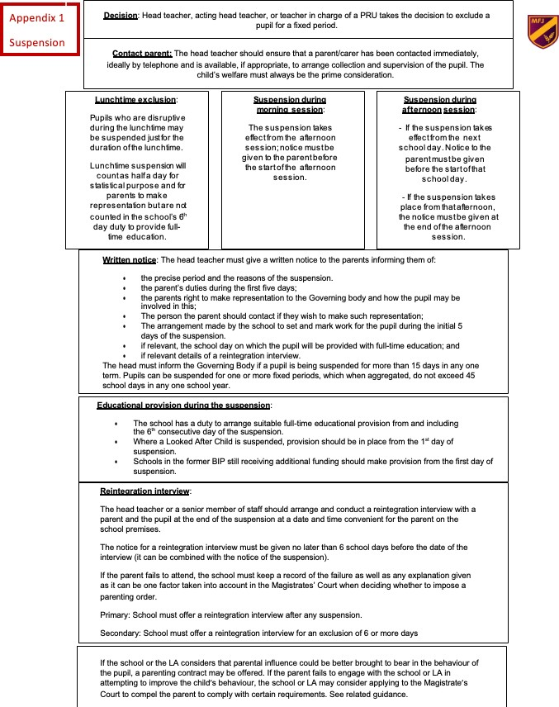

Appendix 2: Permanent Exclusion
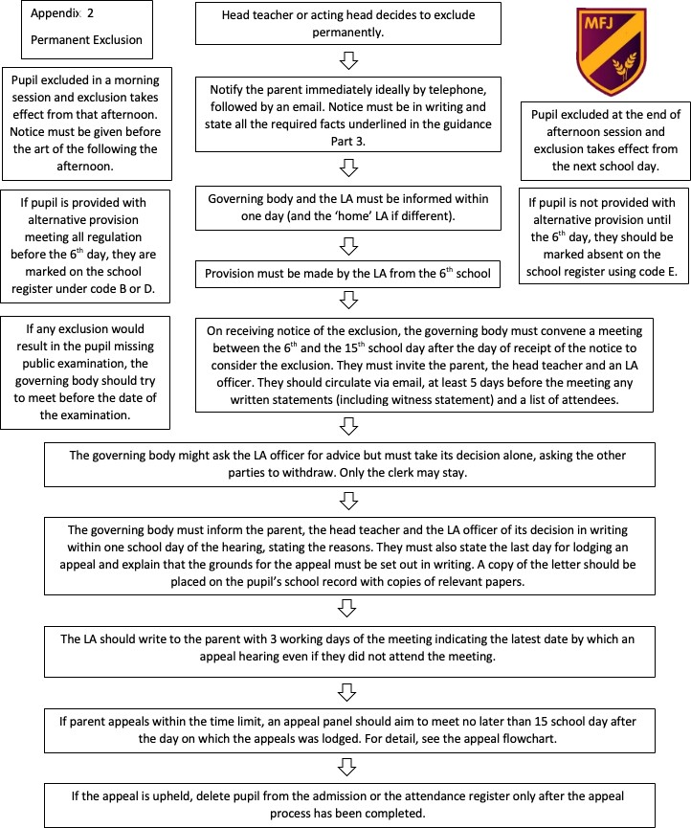

Appendix 3 Exclusion Appeal

