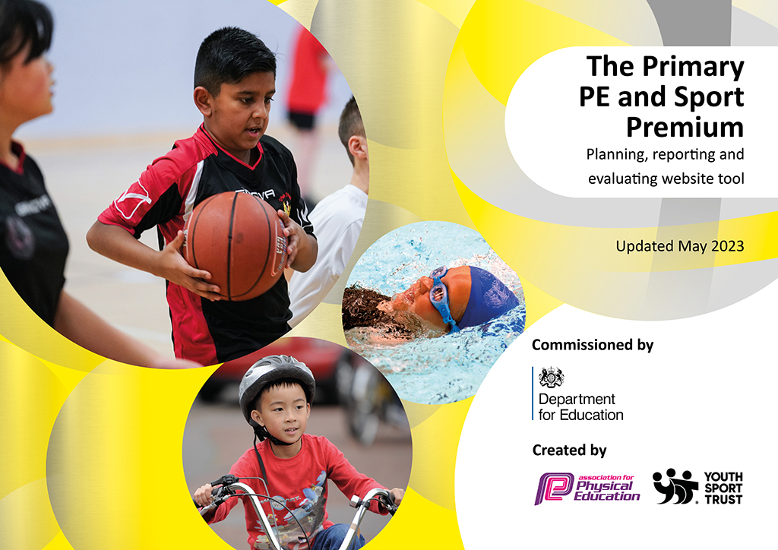
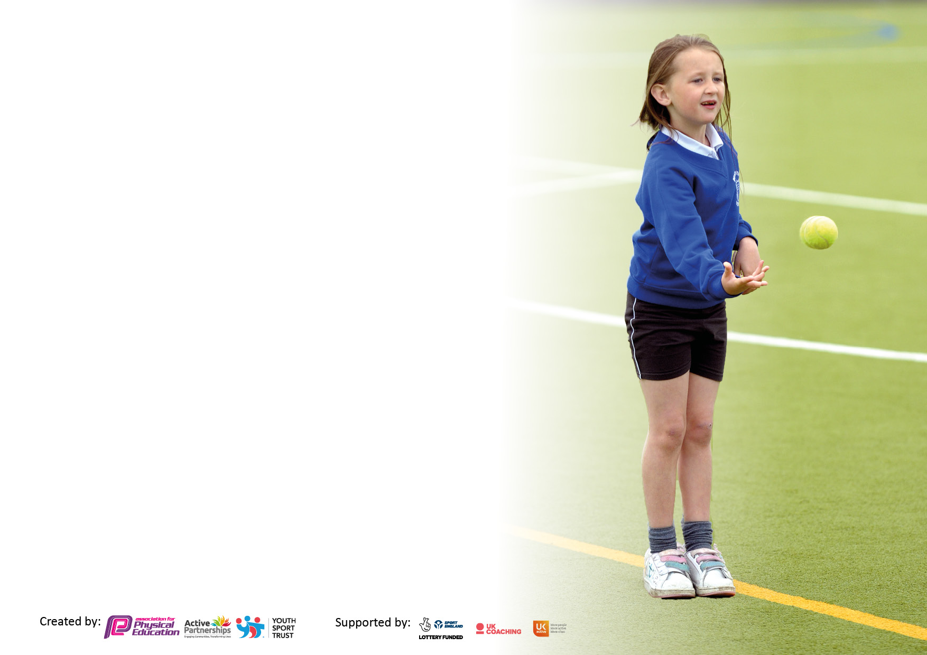

It is important that your grant is used effectively and based on school need. The Education Inspection Framework makes clear there will be a focus on ‘whether leaders and those responsible for governors all understand their respective roles and perform these in a way that enhances the effectiveness of the school’.

Under the Quality of Education Ofsted inspectors consider:
Intent - Curriculum design, coverage and appropriateness
Implementation - Curriculum delivery, Teaching (pedagogy) and Assessment
Impact - Attainment and progress

To assist schools with common transferable language this template has been developed to utilise the same three headings which should make your plans easily transferable between working documents.

Schools must use the funding to make additional and sustainable improvements to the quality of Physical Education, School Sport and Physical Activity (PESSPA) they offer. This means that you should use the Primary PE and sport premium to:

- Develop or add to the PESSPA activities that your school already offer.
- Build capacity and capability within the school to ensure that improvements made now will benefit pupils joining the school in future years.
- The Primary PE and sport premium should not be used to fund capital spend projects; the school’s budget should fund these.

Pleasevisitgov.ukfortherevisedDfEguidanceincludingthe5keyindicatorsacrosswhichschoolsshoulddemonstrate animprovement.Thisdocumentwillhelpyoutoreviewyourprovisionandtoreportyourspend.DfEencouragesschools to use this template as an effective way of meeting the reporting requirements of the Primary PE and Sport Premium.

We recommend you start by reflecting on the impact of current provision and reviewing the previous spend.

Schools are required to publish details of how they spend this funding, including any under-spend from 2021/2022, as well as on the impact it has on pupils’ PE and sport participation and attainment. All funding must be spent by 31st July 2023.

We recommend regularly updating the table and publishing it on your website throughout the year. This evidences your ongoing self-evaluation of how you are using the funding to secure maximum, sustainable impact. Final copy must be posted on your website by the end of the academic year and no later than the 31st July 2023. To see an example of how to complete the table please click HERE.

Details with regard to funding
Please complete the table below.

Total amount carried over from 2021/22 | £0
Total amount allocated for 2021/22 | £20,800
How much (if any) do you intend to carry over from this total fund into 2022/23? | £786
Total amount allocated for 2022/23 | £20,800
Total amount of funding for 2023/23. To be spent and reported on by 31st July 2023. | £ 20014
Swimming Data
Please report on your Swimming Data below.

Meeting national curriculum requirements for swimming and water safety.
,
N.B. Complete this section to your best ability. For example, you might have practiced safe self-rescue techniques on dry land which you can then transfer to the pool when school swimming restarts.
Due to exceptional circumstances priority should be given to ensuring that pupils can perform safe self-rescue even if they do not fully meet the first two requirements of the NC programme of study
What percentage of your current Year 6 cohort swim competently, confidently and proficiently over a distance of at least 25 metres?  N.B. Even though your pupils may swim in another year please report on their attainment on leaving primary school at the end of the summer term 2022.  Please see note above | 56%
What percentage of your current Year 6 cohort use a range of strokes effectively [for example, front crawl, backstroke and breaststroke]?  Please see note above | 44%
What percentage of your current Year 6 cohort perform safe self-rescue in different water-based situations? | 90%-Assemblies delivered to children regarding water safety.
Schools can choose to use the Primary PE and sport premium to provide additional provision for swimming, but this must be for activity over and above the national curriculum requirements. Have you used it in this way? | No

Action Plan and Budget Tracking
Capture your intended annual spend against the 5 key indicators. Clarify the success criteria and evidence of impact that you intend to measure to evaluate for pupils today and for the future.

Academic Year: 2022/23 | Total fund allocated: | Date Updated:
Key indicator 1: The engagement of all pupils in regular physical activity – Chief Medical Officers guidelines recommend that primary school pupils undertake at least 30 minutes of physical activity a day in school |  |  |  | Percentage of total allocation:
 |  |  |  | 34.7%
Intent | Implementation |  | Impact
Your school focus should be clear what you want the pupils to know and be able to do and about what they need to learn and to  consolidate through practice: | Make sure your actions to achieve are linked to your intentions: | Funding allocated: | Evidence of impact: what do pupils now know and what can they now do? What has changed? | Sustainability and suggested next steps:
To raise the standards of all pupils in regular physical activity.  To ensure children meet the 60 minutes of MVPA as recommended by the World Health Organisation. | Review:  - Sports and Health Ambassadors  - After school clubs  - Fun fitness intervention- sports coach  - Sports star- weekly recognition  - Sports equipment for lunchtimes.  - Sports Plus Coach | £7215 | See below | See below
 | Actions:  Sports and Health Ambassadors  Children have received training from the West Bromwich Albion Foundation. They received a two-hour session for a six-week block during Spring 1. Children covered a range of concepts, including effective communication, leadership development and deepening the range of games that they can lead (see purple folder with evidence from the sessions). At lunch time, three days weekly, Sports and Health Ambassadors lead activities with their year group (Year 4 and 5). This involves setting up the game, explaining the rules/scoring methods and then they officiate it. The activities that were selected were designed by the ambassadors and these will rotate on a half-termly basis. The activities so far have included:  - Netball  - Cops and robbers  - Obstacle course  - Dodgeball  - Handball  The aim is for more children to be active at lunch times. This leads them to meeting the recommended 60 minutes of physical activity set by the World Health Organisation.  Moreover, the Sports and Health Ambassadors have helped with the organisaiton of sports day. They discussed what fun (non-competitive activities) that children could participate in. They selected:  - Sack race  - Egg & Spoon race  - Space hopper race  - Bean bag throwing.  On sports day, the ambassadors helped with carrying out the non-competitive activities. They kept track of scores and encouraged participants as they were completing the activities. | £0 | Sports and Health Ambassadors  Sports and Health Ambassadors have been monitored by MO during Spring 2. From the observations, children were carrying out activities well. Children were explaining what the rules and aims of games were to the participants. Some help was needed in setting up the equipment. Timetables were given to the children to ensure they understand what day they are leading the activities and what the activity is.  MO meets with ambassadors once monthly to discuss how they are getting on with their ambassador roles. We discuss situations that they have found difficult, problem-solve solutions and discuss changes to activities and up-coming events that they can get involved with. Ambassadors completed a questionnaire in summer giving their written feedback on their role and improvements that could be made going forwards.  Children in Year 4 and 5 carried out a pupil perception Google forms questionnaire in Summer 2.  The questionnaire looked at the following:  - Do you enjoy the playground activities at lunch times?  - Are you active at lunch times?  - What activities do you play at lunch times?  - What different activities would you like to see at lunch times?  - Do you take part in activities led by the Sports and Health Ambassadors?  Question 1- From the survey, we found that 89.6% children enjoy the playground activities at lunch times.  Question 2- Results found that 47.7% said that they are active at lunch times all the time. 30.6% of children said they are active most of the time. This means that 78.3% of the children are either active most or all of the time, which helps ensure that the children are meeting their 60 minutes of daily exercise a day. This leaves us with 21.7% of children who are sometimes (14.5%), rarely (6.2%) and never (1%) active at lunch times.  Question 3- From the list of activities, the top five games played at lunchtimes were:  - Tag 72%  - Football- 66.3%  - Dodgeball- 65.3%  - Skipping- 52.8%  - Hula-hooping- 36. 8%  Question 4- This question found that children want to see basketball (72%), tennis (71%) and cricket (65%) at lunch times.  Question 5- Regarding ‘do you take part in activities led by the Sports and Health Ambassador?’, 61.7% of children said ‘yes’, they take part in the activities. This means that 38.3% of children do not participate in the ambassador led games. | Sports and Health Ambassadors  Next year, a group of Year 4’s (current Year 3’s) will be selected to carry out the ambassador training with West Bromwich Albion Foundation. They will receive training which looks at building their communication, leadership and teamwork skills. They will then help lead activities at lunch times with their year group.  The current Sports and Health Ambassadors will carry on leading activities at lunch times. Selected Year 6 Sports and Health Ambassadors will carry out activities with Year 3 children at lunch times. This will ensure that each year group will be benefitting from the ambassadors, and allow the ambassadors to display their leadership, communication, and team-work skills.  Year 4 and year 5 ambassadors will carry out activities with their respective year groups.  Regular drop-ins will take place to ensure that children are carrying out the activities well and to encourage other children to take part. MO to meet with ambassadors once monthly to discuss current activities, what things are working well and things we could improve/develop.  A student voice survey will be carried out in summer 2 to capture their thoughts of lunch times and to what improvements could be made moving forwards.  From the feedback, activities that the children have recommended will be added. Purchases have been made of basketball hoops for the playgrounds to ensure the correct provision is provided.  Moki bands will be used to evaluate and analyse the improvements and percentage increase in physical activity during breaktimes and lunchtimes.
 | After school clubs  In this academic year, the following after school clubs, that relate to sport, have taken place at Moat Farm Junior:  - Fitness Club  - Football Club  - Basketball Club  - Netball Club  - Athletics Club  Football Club  In Autumn 1, the School Football team was created for both Years 3&4 and Years 5&6. Trials took place whereby 53 children attended from Years 5&6, which was then narrowed down to a squad of 20. For Years 3 and 4, 51 children turned up and a squad of 14 were selected. Weekly training sessions take place to ensure children can develop their skills, understand the importance of working together in a team and for preparation for competitions. | £0 | In summer 2, children in years 3, 4 and 5 completed a short questionnaire (pupil perception) asking what after school clubs they have participated in this year and what after school clubs, they would like to see at Moat Farm.  From this pupil voice, I found that 52.8% of these children attended an after-school club, linked to sport, this year. Below displays the percentages which make up the 47.2% who did attend after school clubs:  - Fitness Club- 25.2%  - Football Club- 11%  - Basketball Club- 3.7%  - Netball Club- 3.7%  - Athletics Club- 3.7%  To improve our current provision, children were then asked in the questionnaire what after-school clubs they would like to see next year (excluding the ones we currently provide). From this, I found that these activities outnumbered all others:  - Dodgeball- 68.8%  - Bench ball- 45.5%  - Dance- 39.1%  - Gymnastics- 34.4%  - Tennis- 34.9%  On personal reflection of the after-school clubs, I think it’s important to offer a wider range of activities, for all groups of children. The number of boys who attend after-school clubs (72% of current participants) currently outweighs that of girls. Therefore, I think to boost both the number of girls attending after school clubs and the number of children overall attending after school clubs then a wider provision is needed. | Next year, we will continue to offer existing sports clubs due to the positive feedback from pupils, staff and verbal discussions with parents.  To improve the after-school clubs we offer in school, I intend to offer an after-school club for each of the top five recommended by the children. External coaches will be used for dance, gymnastics, and tennis. Internally we will provide children with the opportunity to participate in bench ball and dodgeball club. Children who are yet to attend a club will be targeted first.
 | Sports Plus Coach  Sports Plus coaches are used to deliver one PE, with each class, once fortnightly. They will help promote the importance of physical activity, sport and PE through the health and fitness sessions and to deliver fun fitness sessions for SEND children. | £7215 | Sports plus have helped deliver a range of lessons in school during PPA days.  They have delivered health and fitness sessions to years 3, 4 and 5.  Interventions with SEND children and behavioural groups have taken place to help raise physical activity levels amongst these children (particularly those who are reluctant). | Next steps, to monitor the teaching of Sports Plus coach to ensure that lessons are ‘good’, in line with school expectations and policy and all learners are accessing the activities.
Key indicator 2: The profile of PESSPA being raised across the school as a tool for whole school improvement.  Key indicator 5: Increased participation in competitive sport  Key indicator 4: Broader experience of a range of sports and activities offered to all pupils. |  |  |  | Percentage of total allocation:
 |  |  |  | 56.7%
Intent | Implementation |  | Impact
Your school focus should be clear what you want the pupils to know and be able to do and about what they need to learn and to  consolidate through practice: | Make sure your actions to achieve are linked to your intentions: | Funding allocated: | Evidence of impact: what do pupils now know and what can they now do? What has changed? | Sustainability and suggested next steps:
To promote the culture of health and fitness across Moat Farm Junior.  To ensure children are leading a balanced, active healthy lifestyle. | Review:  - Hosted competitions  - Local Authority competitions, including the Black Country Games  - Weightlifting sessions  - Moat Farm University- golf  - Health and fitness sessions- delivered by coach.  - Sports Week | £11802 | See below. | See below.
 | Hosted competitions  To increase the participation levels in competitive sport, we hosted two mixed Year 5 and 6 football tournaments at Moat Farm Junior. We invited four schools in autumn 1 and five schools in spring 2 to participate. Each school, including Moat Farm, selected 10 children (including 2 girls) to participate in the tournament. The tournament took place on the school field and each school played a minimum of 4 games (tournament 1) and 5 games (tournament 2), leading onto finals.  For their participation, all children received a participation medal, and the winning school received a trophy. | £ 152  (Cost for medals, trophy) | Schools that attended gave very positive verbal feedback. The children really enjoyed the day and learnt the importance of showing respect, kindness and teamwork, linking to our Moat Farm values.  Children were keen to ask when the next tournaments were and love sharing their success with their peers. This helps develop a passion for being active and promotes responsibility in representing school. | Next year, we intend to host two more football tournaments at Moat Farm. We would love to branch it out to more schools in Sandwell. This will help, not just competitive sport at Moat Farm, but also across Sandwell.  Moving forward, to raise the profile of other sports we intend to host other sports tournaments at Moat Farm. Other schools will be invited to participate.
 | Local Authority competitions  At the beginning of the year, SLT, MO and EB, discussed the local authority competitions that we would like our children to attend. The competitions selected are based on the competition calendar sent by Sandwell Games lead Hayley Fisher. The competitions that were selected are as followed:  Autumn term  - SEND football (Wednesday 16th November).  - West Bromwich Albion Foundation Year 5 and 6 football tournaments (Thursday 24th November).  - Basketball tournament Year 5 and 6 (Wednesday 30th November)  - Year 5 and 6 Unified basketballs (Thursday 1st December).  Spring term  - Year 3 and 4 girls’ football (Monday 6th February).  - Year 5 and 6 Sports hall athletics (Thursday 2nd March).  - Key Stage 1-2 Boccia (Tuesday 14th March)  - Year 3 and 4 boys football tournament (Monday 20th March).  - Athletics (Sandwell Games) -Thursday 23rd March.  Summer term  - Year 3-6 SEND athletics (Tuesday 25th April)  - Year 5-6 Netball (Tuesday 23rd May)  - Black Country Games- Year 3/4/5/6. | £412 (cost for taxis, equipment etc). | To give children the exposure to a wide range of competitive sport opportunities. The aims varied from trying to allow gifted and talented learners to showcase their talents, giving other learners an opportunity to engage within a specific activity. | Continue to offer a wide range of competitions using the Sandwell Games to help engage and inspire a range of learners in sports and to give gifted and talented children the opportunity to showcase their talents against other children in the local area.
 | Weightlifting taster sessions  To raise the profile of PESSPA across school, contact was made with a local secondary school- Oldbury Academy. They were offering an opportunity for children to receive taster session. As a school, we decided to target children who are normally reluctant during PE sessions to give them exposure to a totally different physical activity and try to build their resilience, confidence and self-esteem. | £0 | In total, 94 learners received the taster session. The children learnt how to carefully and safely perform two lifts and explored the benefits of weightlifting and being physically active. The children loved carrying out the activity. Medals were awarded to the ‘top lifters within the sessions’ who displayed the correct technique or who showcased key values like respect, perseverance and resilience. | In the future, we are intending to carry on working with the Oldbury weightlifting team. Discussions have taken place about taking groups of children to Oldbury to receive a more in depth six-week training programme, which looks at building on the skills taught this year. Discussions with SLT will take place as to which children would benefit from this training and this will be organised ready for the autumn term.
 | Golf intervention  During spring 1 and 2, eight children who were normally reluctant to participate in PE were selected to participate in a golf intervention. The aim was to give children exposure to an area of sport which was not on our curriculum and give them an insight into the skills needed. Throughout the process, the children explored:  - What is golf?  - Key golf terminology e.g., putt, swing, chip, par etc.  - How to successfully chip the ball using the Tri-Golf wedge.  - How to successfully putt the ball using a putter.  - How to swing the golf club to increase and reduce distance.  - Target practice  - Build their own crazy golf course. | £0 | During the sessions, the eight children learnt the basics and fundamental skills of Tri-Golf. The children learnt how to putt and chip using a putter and wedge respectively. The children learnt when each shot was used, the basic scoring system in golf and the importance of precision and power when performing the shot.  To encourage their creativity and imagination, the children created their own crazy golf hole in the hall. They used benches, gymnastics apparatus and cones to design their own golf hole and then participated in a mini tournament. During this tournament the Moat Farm Values of teamwork and friendship were discussed and showcased by the children. It was key for them to work together and communicate effectively to produce a golf hole that they could explain to their peers. | In the future, we intend to take the children offsite to carry out a golfing activity i.e., crazy golf, pitch and putt activity, as a chance for them to showcase what they have learnt during the golfing unit.
 | Health and fitness sessions  To promote health and fitness across school, each class will receive sessions linked to health and fitness. Children will look at:  - What constitutes a healthy diet.  - How to be physically active.  - How to manage emotions when being physically active.  We feel that this will give children the fundamentals needed to understand how diet and exercise play an important role in being healthy. Moreover, we feel that children benefit from learning that managing their emotions when being physically active will hopefully reduce conflicts and disagreements- which allows children to be active for longer and enable everyone to enjoy themselves in the process. | Cost incurred with Sports Plus coach (timetabled) | Year 4 and 5 have received the three sessions and evidence has been recorded in PSHE books. | Due to timetabling and curriculum constraints, only years 3, 4 and 5 have received the health and fitness sessions this year. Moving forward, timetables will be made from September to ensure all children receive these sessions.
 | Moki bands  These bands are used to track the physical activity levels of children. | £2900 | N/A | Moving forward, Moki bands are going to be used to track the physical activity of levels of a smaller sample size in each class during PE lessons. This will be used to track the data before and after the training of SHARP principles to see if the training has had a positive impact.
 | Playground and PE equipment  A wider range of equipment to be purchased to improve the physical activity levels at lunchtimes. To ensure that more children are active ‘all’ or ‘most of the time’ during breaks. | £8160 | A range of equipment has been purchased to help improve the provision for lunchtimes. This ranges from:  - New football goals  - Basketball hoops  - Bibs and tags  - Dodgeballs  - Netballs  See date above regarding physical activity levels at lunch times. | Use feedback from pupil voice to provide more equipment and resources to engage children in being physically active at lunch times.  Continue to meet with Sports and Health Ambassadors throughout the year to see what activities are going well or if they have any recommendations for new activities.  Use Moki bands to evaluate percentage increase in physical activity.  Complete pupil voice in summer 2 to ascertain children’s thoughts at lunch times.
 | Sports Week  To promote physical activity in school, the week commencing Monday 19th June, we are hosting a sports week in school. The aim of the week is to promote the culture of PE, physical activity, and competitive sport.  Each year group has their own individual sports day, and a finals afternoon will take place for children who finished 1st in the competitive events for their group.  Meet with staff to discuss the sports day events. Produce an information pack with rules and scoring sheets. | £150 | All children received a participation sticker to congratulate them for taking part in all the activities and gaining points which contributed towards their house colours overall total.  On the final’s afternoon, 64 medals were awarded to 60 children (from years 3 to 6). These gold, silver and bronze medals were awarded to the 1st, 2nd and 3rd places respectively for each year group for the four competitive events.  Children received medals on the podiums in front of their peers. | Next year, continue to host a whole school sports week to raise the profile of PE, sport and physical activity.  Due to the success of having a finals afternoon it would be great to replicate this again next year and look at ways of extending the number of events that children can compete for medals in.  Discussions with staff to obtain their feedback on sports week.

Key indicator 3: Increased confidence, knowledge and skills of all staff in teaching PE and sport |  |  |  | Percentage of total allocation:
 |  |  |  | 4.9%
Intent | Implementation |  | Impact
Your school focus should be clear | Make sure your actions to | Funding | Evidence of impact: what do | Sustainability and suggested
what you want the pupils to know | achieve are linked to your | allocated: | pupils now know and what | next steps:
and be able to do and about | intentions: |  | can they now do? What has
what they need to learn and to |  |  | changed:
consolidate through practice:
Increase confidence, knowledge and skills of staff teaching PE and Sport. | Review:  - Dance desk  - Staff meetings delivered by subject lead.  - Created a new OAA curriculum with progression of skills.  - Complete PE- scheme of work. | £1,025 | See below | See below
 | Dance desk (CPD)  CPD description  To provide consultancy for each school who subscribes to the Primary PE.  Package creating a network of support, co designed by the schools in the network.  A minimum of 2 CPD opportunities.  3 Network sessions one per term to share and disseminate practice.  On-line national updates and curriculum support  1.1 meeting with Subject Lead  or ECT support, Quality Mark  Membership of your National Professional Associations  2 years membership AfPE National Subject Association  2years membership One Dance UK Subject Association Dance  1 year membership YST plus CPD  sustainable online support /Webinars from all | £850 | Receiving the Dance desk CPD has given PE led the opportunity to meet with PE leaders in the Local Authority, discuss key improvements and the latest updates in the subject and to share good practice. From the session I attended in summer 2, the focus of the course was centered around swimming and a guest speaker focused on ‘physical literacy’. Key takeaways from the meeting were on how physical literacy should be embedded across the curriculum, not just in PE, and how to implement certain aspects across school. | To continue to build physical literacy into all aspects of PA, sport and PE. This will coincide with sports initiatives and key events throughout the next academic year.  Sign up to the new dance desk membership to continue CPD for MO.
 | Staff meetings delivered by subject lead | £0 | Staff meeting 1.  A staff voice reflection was conducted during the PE staff meeting (11/10/22). The reflection consisted of staff anonymously shared their thoughts of PE. Key words were placed on a PowerPoint slide which related to the many different aspects of PE and Sport- see subject lead folder. From the staff voice, many areas were highlighted that staff feel need improving in PE and things they need help with going forward.  Pupil perception 1  Triangulating this with student voice and discussions with previous PE lead & SLT members, I have decided to focus on three areas:  - Warm up and cool down activities.  - Subject knowledge & lesson planning- in particular dance and athletics.  - Differentiation for SEND & MA children.  Staff meeting 2  The focus of the staff meeting was on how to deliver an effective warm-up. Staff discussed and explored what constitutes a successful warm-up. A key message shared with staff that was dynamic stretching needs to take place alongside a pulse raising activity. I shared with staff different warm-up games that could be played for a variety of lessons to ensure pupils are ready for exercise. Finally, we discussed the terminology that needs to be used when children are explaining why we warm-up before physical activity in relation to the body. | Continue to deliver sessions centered around the SHARP principles. This will be the benchmark and research that will help raise the standards of teacher expertise and practice in PE. The focus next year will be to continue to embed work on warm-ups, explore methods of ensuring children are carrying out MVPA (moderate to vigorous physical activity) for large amounts of the lesson.  Use MOKI bands to track MVPA levels of a small sample size of children which can be used to identify groups of children who may need extra activities to raise their physical activity levels and which staff may need further CPD/team-teaching opportunities to raise the PA levels in their PE lessons.  Posters for classes which display the importance of warm-ups and key vocabulary which they can retrieve during the early part of the lesson.  Carry out staff perception in autumn 1 to ask how confident staff are at delivering PE. Also, to gain their thoughts of positives, areas of development and areas of support staff need in the subject.
 | Complete PE and curriculum coverage | £175+ VAT | Complete PE has been used as a planning tool for PE. | New dance unit across school in the autumn 1. The new athletics unit across school in the summer 1.  Introduction of Tri-Golf to the curriculum.  Monitoring the delivery of PE across school through learning walks/drop-ins. Discussions with staff, after each half-term, regarding the units taught.

Signed off by
Head Teacher: | Mrs. L Stone
Date: | 24th July 2023
Subject Leader: | Mr. M Oldfield
Date: | 24th July 2023
Governor: | Mrs. D Walker
Date: | 24th July 2023

