Geography
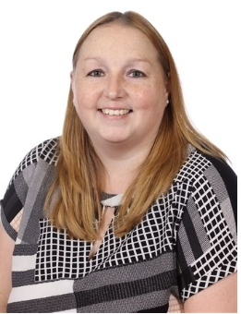
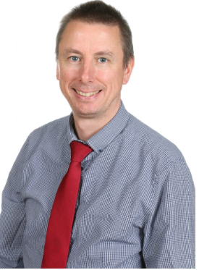

Our geography leaders are Mrs Miles and Mr McCormick.
INTENT
At the heart of our curriculum are our school curriculum drivers – Diversity, Responsibility and Opportunities. The drivers shape our curriculum, bring about the aims and values of our school, and respond to the needs of our community. Here at Moat Farm Junior School, we believe that a high-quality geography education should inspire in pupils a curiosity and fascination about the world and its people that will remain with them for the rest of their lives. We aim to provide children with the knowledge about diverse places, people, resources and natural and human environments, together with a deep understanding of Earth’s key physical and human processes.

Our curriculum for geography aims to ensure that pupils can:

- Develop contextual knowledge of the location of globally significant places – both terrestrial and marine – including their defining physical and human characteristics and how these provide a geographical context for understanding the actions of processes.

- Understand the processes that give rise to key physical and human geographical features of the world, how these are interdependent and how they bring about spatial variation and change over time.

- Are competent in the geographical skills needed to:
- Collect, analyse and communicate with a range of data gathered through experiences of fieldwork that deepen their understanding of geographical processes
- Interpret a range of sources of geographical information, including maps, diagrams, globes, aerial photographs and Geographical Information Systems (GIS)
- Communicate geographical information in a variety of ways, including through maps, numerical and quantitive skills and writing at length.

IMPLEMENTATION
Here at Moat Farm Junior School, geography is delivered in the form of discrete lessons. Milestones are used to ensure that pupils progress and improve skills in the aspects of geographical enquiry. Geography planning is personalised to the needs of pupils, challenging them and building on previous learning. To further support this, teachers plan lessons based upon our “basic, advancing and deep” structure which runs through the wider curriculum.

During their time at our school, children extend their knowledge and understanding beyond the local area to include the United Kingdom and Europe, North and South America. This will include the location and characteristics of a range of the world’s most significant human and physical features. Children are taught to develop their use of geographical knowledge, understanding and skills to enhance their locational and place knowledge. Resources, such as maps, atlases, aerial photographs and ICT are used consistently to support children’s learning.

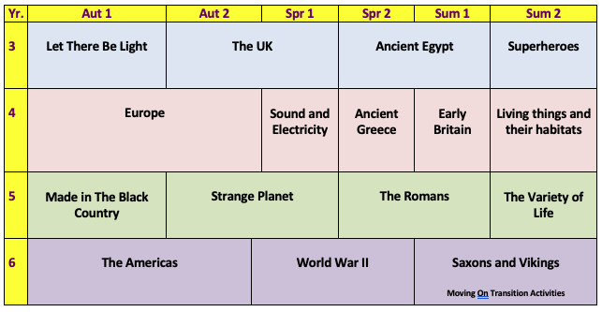
To further support the teaching of geography, pupils are afforded the opportunity to visit geographical sites and experience visitors in school.

IMPACT
At Moat Farm Junior School, we want to inspire in our children a curiosity and fascination about the world and its people that will remain with them for the rest of their lives. In order to achieve this, our children will develop:

- An excellent knowledge of where places are and what they are like.
- An excellent understanding of the ways in which places are interdependent and interconnected and how much human and physical environments are interrelated.
- An extensive base of geographical knowledge and vocabulary.
- Fluency in complex, geographical enquiry and the ability to apply questioning skills and use effective analytical and presentational techniques.
- The ability to reach clear conclusions and develop a reasoned argument to explain findings.
- Significant levels of originality, imagination or creativity as shown in interpretations and representations of the subject matter.
- Highly developed and frequently utilised fieldwork and other geographical skills and techniques.
- A passion for and commitment to the subject, and a real sense of curiosity to find out about the world and the people who live there.
- The ability to express well-balanced opinions, rooted in very good knowledge and understanding about current and contemporary issues in society and the environment.

We monitor the impact of our geography provision through half termly whole school pupil perceptions, termly assessments, lesson observations and monitoring of geography books.

