Moat Farm Junior School
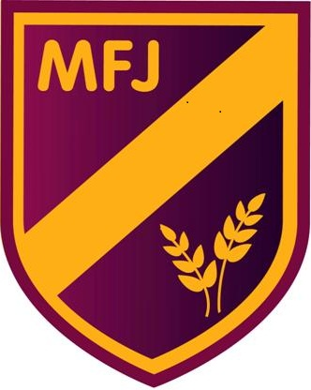

September 2020 – year 3

This is the main entrance.
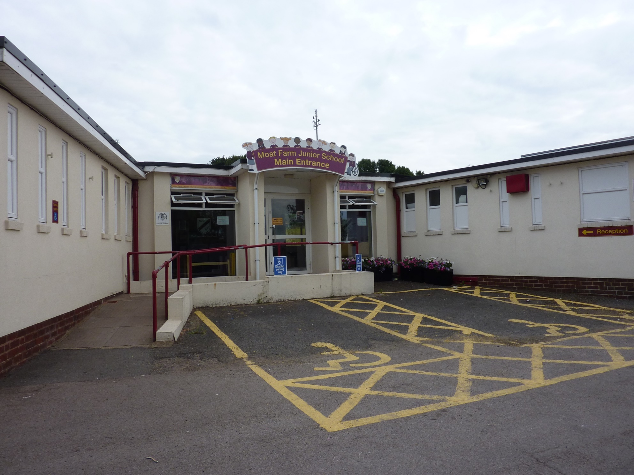

This is the door I will use to go in to school at the beginning of the day.
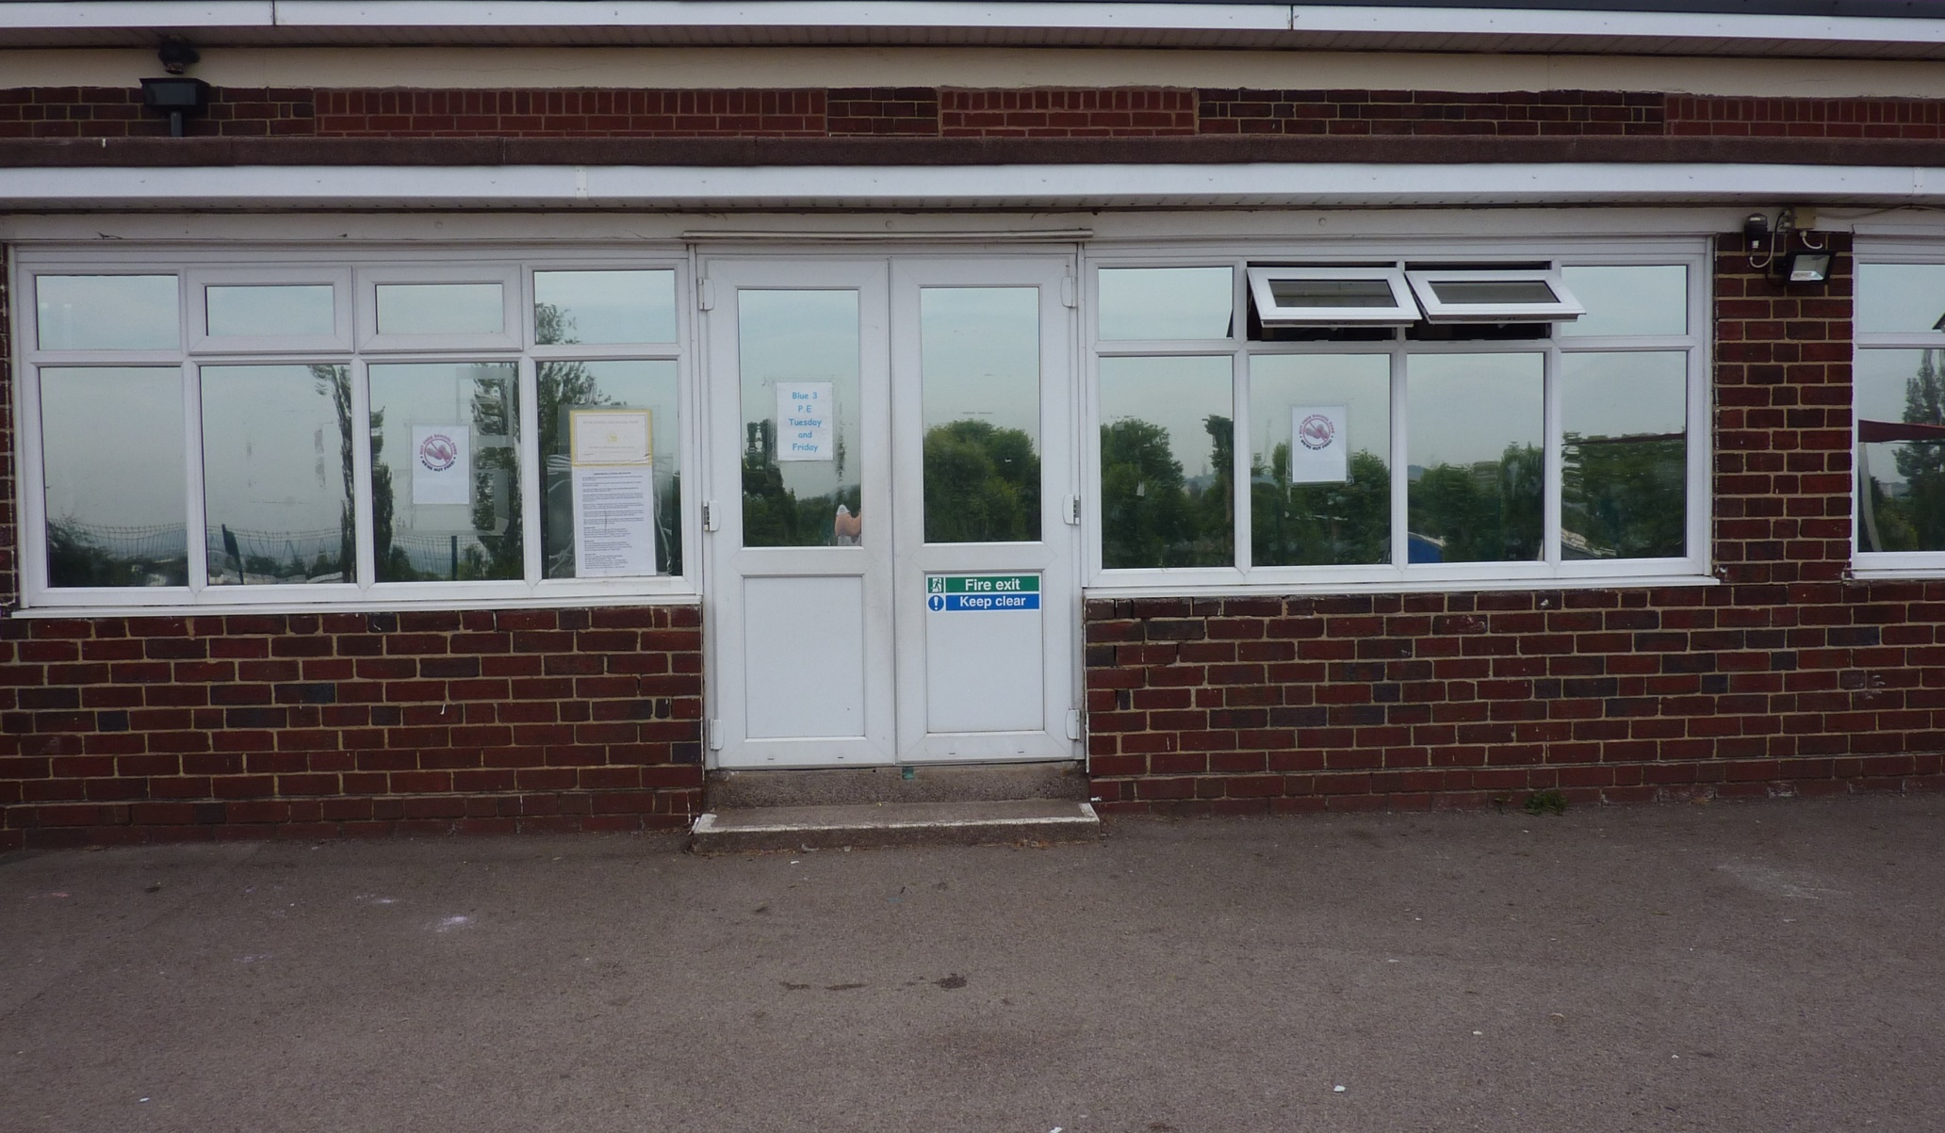

These are the lockers where I will put my coat and bags.
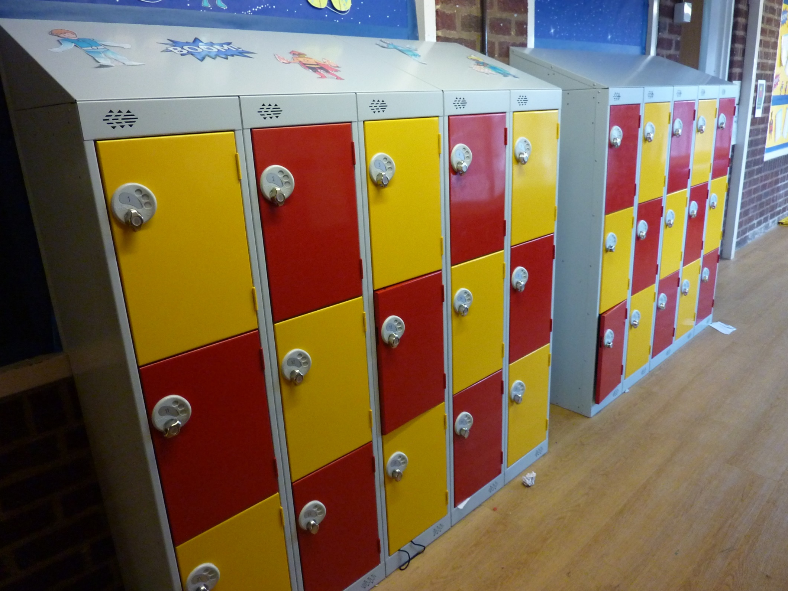

This is a year 3 classroom.
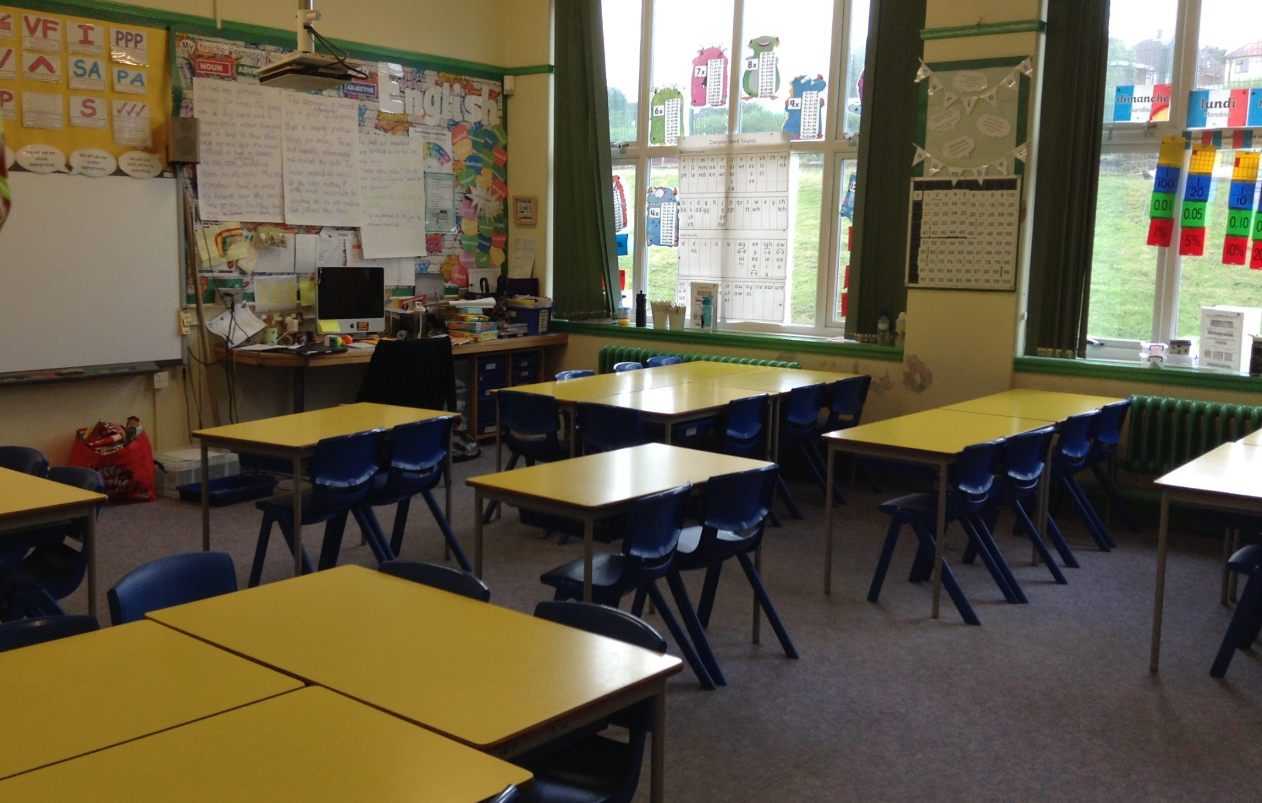

This is my playground in year 3.
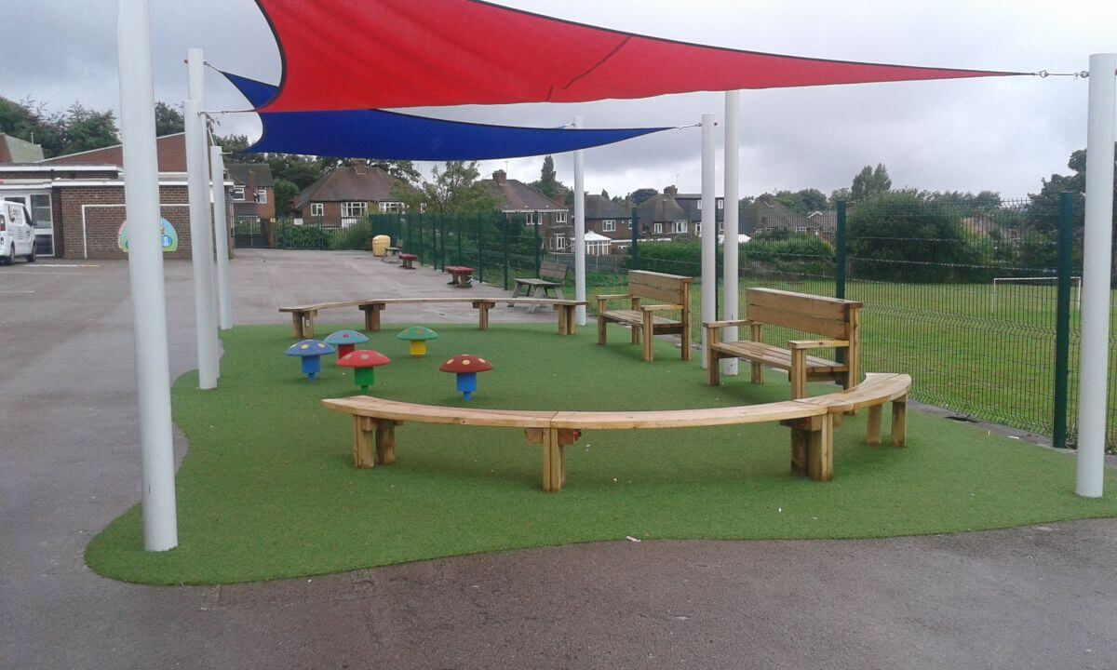

This is the gym, where we have PE lessons and assemblies.
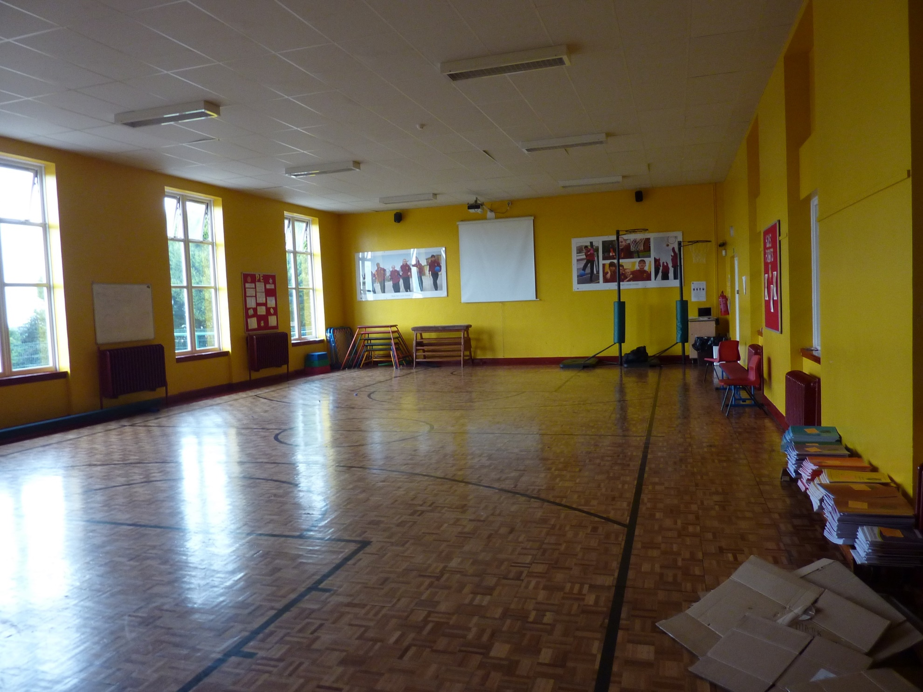

This is where I can go to change my reading book.
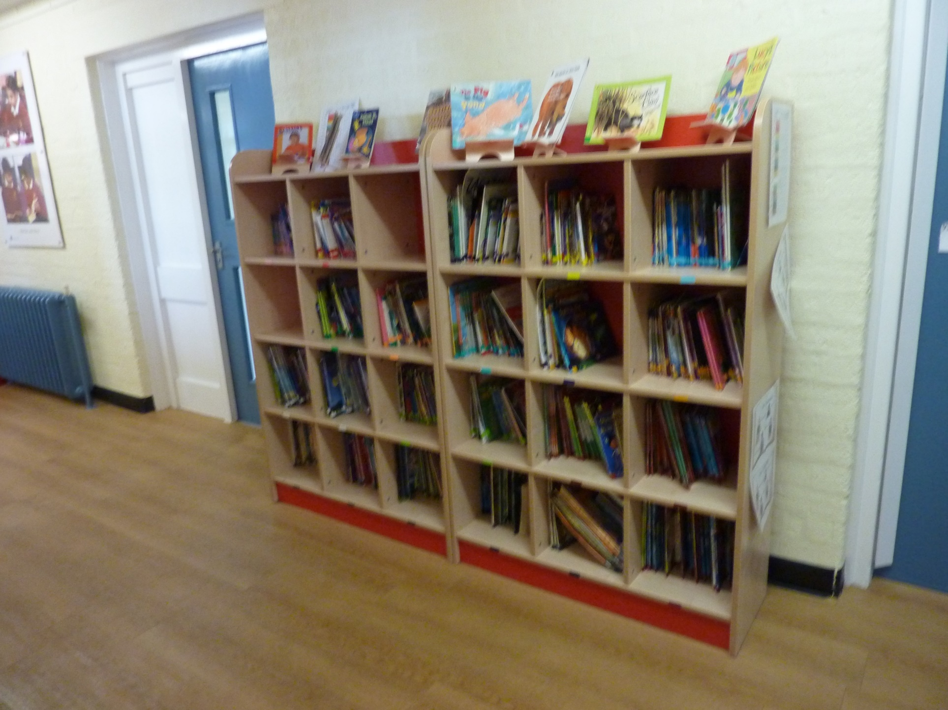

This is the library, where I can borrow library books from.
