TRANSITION YEAR 6

**Q4k’s**

Dear parents and children

We hope you are well

Here is a resource used by the teachers at Q3 Langley for the students in year 7. The resources are called Quest for Knowledge and they are knowledge organisers for the subjects you will be studying in year 7 and beyond.

Have a look through and prepare yourselves- don’t worry if you don’t get through all of these, you will be using some of these when you start school.

There is a video <https://www.youtube.com/watch?v=7fHemXKpV88> – on the Q3 Langley You Tube site that explains how to use the Q4K’s. Please feel free to use this to support how the student’s use a Q4K.

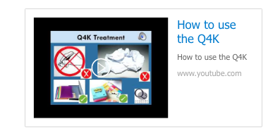

For any questions or queries regarding any of the transition work please email and we will endeavour to help you.

Please email [Transitionyear6@moatfarm-jun.sandwell.sch.uk](mailto:Transitionyear6@moatfarm-jun.sandwell.sch.uk)

Thank you