Dear Parent/Carer

We would like to give parents the opportunity to write their child a short note, wishing them all the best for the start of their secondary school journey. These notes will be given to the students on the after their first full week at Oldbury Academy. It is a nice way for the students to review their first week, and read a positive message from their parents, and also something for them to keep.

Please complete the section below and either send it back to us, or post to us. We will then print on gold paper.

Please do not tell your child about this, as we would like this to be a surprise for them.

Yours faithfully,
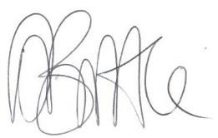
Mr D.S.Brittle
Transition Coordinator

Dear Form:

From
Date:

