Gardening Blog

Greetings fellow-gardeners!
Hope you’re keeping safe and well, and you’re able to enjoy your plants wherever and however you’re growing them!
Mr Gregory and I just wanted to share with you some amazing things from the school garden – some of you actually planted or sowed them yourselves in Gardening Club!!

Our first, delicious-looking onion!

Sweet Peas!

Tasty peas!

Great garlic!

Healthy young fruit trees!

Potatoes sleeping in their beds!

Healthy herbs!

Now, if you haven’t yet sown or planted anything yet, it’s definitely not too late! Try to get hold of baby vegetable plants, like courgettes or tomatoes, or sow seeds like radishes and carrots or winter veg, such as cabbages and parsnips.

Remember, gardening is REALLY good for your mind and your body. So…

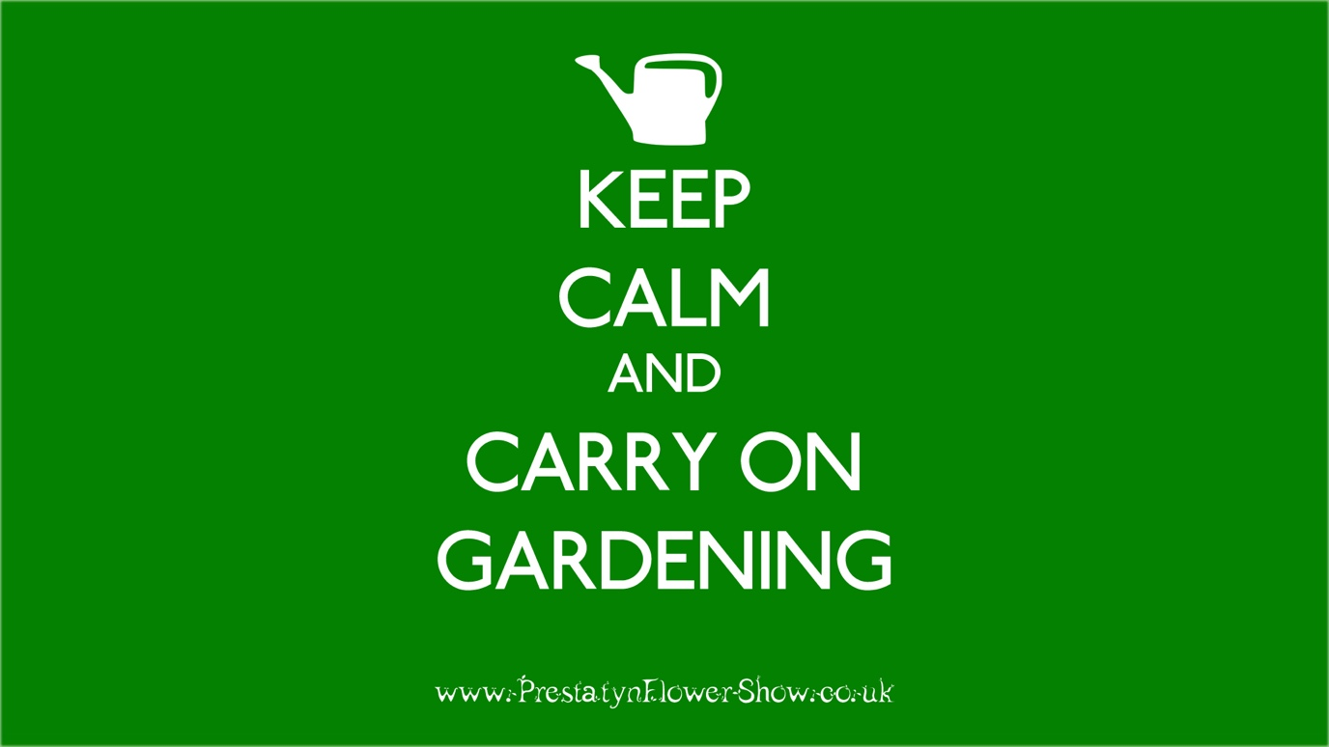

Best wishes,
Mr Gregory and Mr Adams

