Art Activity

Origami Koala Bookmark

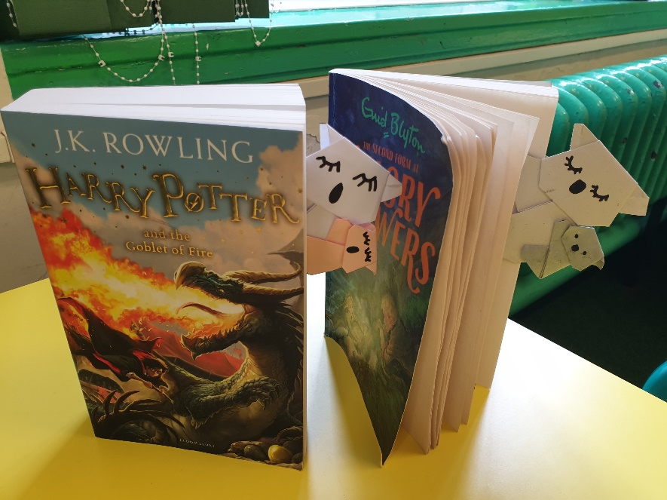
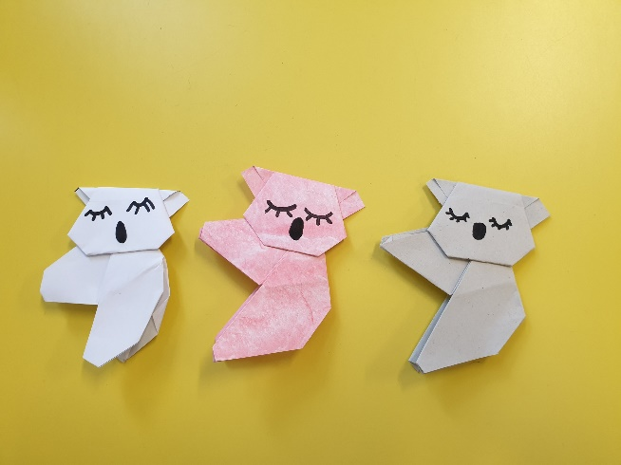
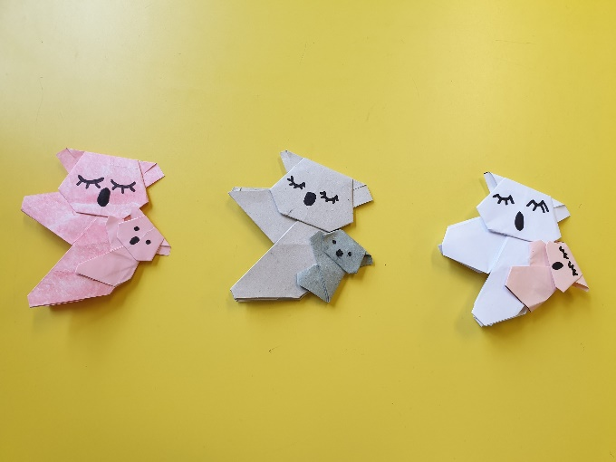

Reading lots of wonderful books at home? Keep losing your place? Why not try making a bookmark in a creative way?

You will need
- Paper
- Pen
- Scissors
- Glue
- Ruler
- Pencil

**Note: Use your pen and pencil to measure the paper to size.
Big Koala: Body- 13cm x 13cm and Head- 9cm x 9cm
Small Koala: Body- 7cm x 7cm and Head- 5cm x 5cm

Follow the link below, remember you can pause the video at each step.

https://www.youtube.com/watch?v=DZs8lXwqQDg

**Top Tip: You can reinforce a crease by running the side of your thumbnail along the fold or gently using the end of a plastic ruler.

Have fun!

